

**DEPT. of Computer Science Engineering**

**SRM IST, Kattankulathur – 603 203**

**SUBJECT CODE AND NAME: 18CSC206J - Software Engineering and Project Management**

**FACULTY NAME:-** **Mrs. C. G. Anupama**

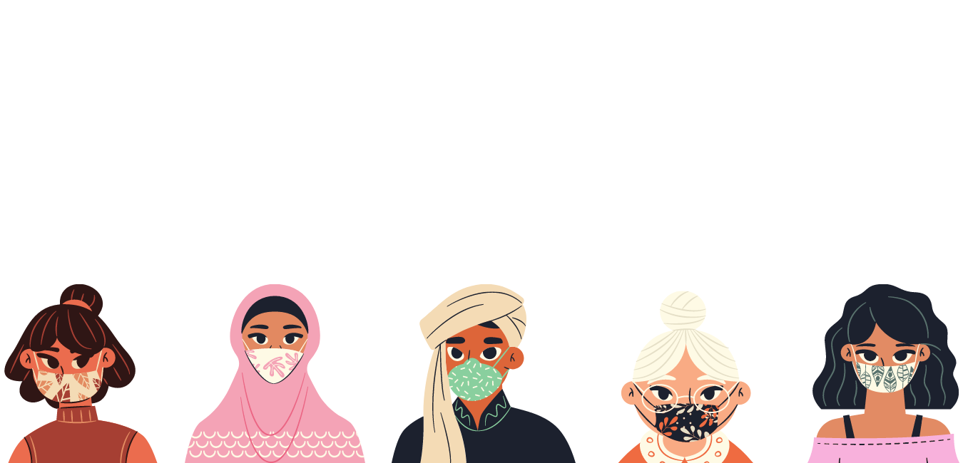

**SUBMITTED BY :**

**DIVYA S GUPTA (RA1911003010454)**

**ANUSHKA (RA1911003010450)**

**DINESH GUDIMETLA (RA1911003010459)**

**Experiment 1A : To identify the Software Project**

**Aim**

To Frame a project team, analyze and identify a Software project

**Project Description:**

Wearing a face mask is now-a-days very important when we are in public places, to protect ourselves and prevent the spread of pathogens that cause these diseases among people around us. The aim of this project is to know whether each and every individual is wearing a face mask to prevent the spread of infectious diseases. Face Mask detection systems are much more efficient in detecting if one is wearing a mask than manual checking.

On applying this system on a Live Video Camera and with further improvements, these types of models could be integrated with CCTV cameras to detect and identify people without masks. This in turn helps during security checks in the airports, offices, schools etc. We will learn to build a Face Mask Detector using Keras, Tensorflow, MobileNet and OpenCV. Also, MobileNetV2 architecture is used to improve its efficiency and accuracy. Furthermore, it would be easy to deploy the model to Embedded systems.

This system can therefore be used in real-time applications which require face-mask detection for safety purposes due to the outbreak of Covid-19. This project can be integrated with embedded systems for application in airports, railway stations, offices, schools, and public places to ensure that public safety guidelines are followed.

**Result:** Thus, the project team formed and the project is described.

**Experiment 1B : Create Business Case, Arrive at a Problem Statement**

**Aim:**

To create a business case and Arrive at a Problem Statement for Face mask detection project.

Table of Contents

**1. Executive Summary**

**2. Strategic Business Context**

**2.1. Business Need**

**2.2. Business Outcomes**

**[3. Detailed Business Problem](https://docs.google.com/document/d/1NLYii6FY6sNrC3yWBW60luGiPAiHvc13zkX6rhemeAM/edit#heading=h.17dp8vu)**

**[3.1. Problem/Opportunity Statement](https://docs.google.com/document/d/1NLYii6FY6sNrC3yWBW60luGiPAiHvc13zkX6rhemeAM/edit#heading=h.3rdcrjn)**

**[3.2. High Level Requirements](https://docs.google.com/document/d/1NLYii6FY6sNrC3yWBW60luGiPAiHvc13zkX6rhemeAM/edit#heading=h.26in1rg)**

**[3.3. Assumptions](https://docs.google.com/document/d/1NLYii6FY6sNrC3yWBW60luGiPAiHvc13zkX6rhemeAM/edit#heading=h.lnxbz9)**

**[3.4. Constraints](https://docs.google.com/document/d/1NLYii6FY6sNrC3yWBW60luGiPAiHvc13zkX6rhemeAM/edit#heading=h.35nkun2)**

**[3.5. Dependencies](https://docs.google.com/document/d/1NLYii6FY6sNrC3yWBW60luGiPAiHvc13zkX6rhemeAM/edit#heading=h.1ksv4uv)**

**[3.6. Stakeholder Analysis](https://docs.google.com/document/d/1NLYii6FY6sNrC3yWBW60luGiPAiHvc13zkX6rhemeAM/edit#heading=h.44sinio)**

**[4. Detailed Analysis](https://docs.google.com/document/d/1NLYii6FY6sNrC3yWBW60luGiPAiHvc13zkX6rhemeAM/edit#heading=h.23ckvvd)**

**[4.1. Evaluation Criteria](https://docs.google.com/document/d/1NLYii6FY6sNrC3yWBW60luGiPAiHvc13zkX6rhemeAM/edit#heading=h.z337ya)**

**[4.2. Cost of each Possible Options](https://docs.google.com/document/d/1NLYii6FY6sNrC3yWBW60luGiPAiHvc13zkX6rhemeAM/edit#heading=h.3j2qqm3)**

**[4.3. Risks](https://docs.google.com/document/d/1NLYii6FY6sNrC3yWBW60luGiPAiHvc13zkX6rhemeAM/edit#heading=h.1y810tw)**

**[5. Implementation & Governance](https://docs.google.com/document/d/1NLYii6FY6sNrC3yWBW60luGiPAiHvc13zkX6rhemeAM/edit#heading=h.4i7ojhp)**

**[5.1. Required Skills](https://docs.google.com/document/d/1NLYii6FY6sNrC3yWBW60luGiPAiHvc13zkX6rhemeAM/edit#heading=h.2xcytpi)**

**[5.2. Milestone](https://docs.google.com/document/d/1NLYii6FY6sNrC3yWBW60luGiPAiHvc13zkX6rhemeAM/edit#heading=h.1ci93xb)**

**[5.3. Change Management](https://docs.google.com/document/d/1NLYii6FY6sNrC3yWBW60luGiPAiHvc13zkX6rhemeAM/edit#heading=h.3whwml4)**

**[5.4. Performance Measurement](https://docs.google.com/document/d/1NLYii6FY6sNrC3yWBW60luGiPAiHvc13zkX6rhemeAM/edit#heading=h.2bn6wsx)**

**[6. Project Charter](https://docs.google.com/document/d/1NLYii6FY6sNrC3yWBW60luGiPAiHvc13zkX6rhemeAM/edit#heading=h.qsh70q)**

**[6.1. Simplified Project Charter](https://docs.google.com/document/d/1NLYii6FY6sNrC3yWBW60luGiPAiHvc13zkX6rhemeAM/edit#heading=h.3as4poj)**

**[6.2. Project Team Structure](https://docs.google.com/document/d/1NLYii6FY6sNrC3yWBW60luGiPAiHvc13zkX6rhemeAM/edit#heading=h.1pxezwc)**

**[6.2.1. Roles & Responsibilities](https://docs.google.com/document/d/1NLYii6FY6sNrC3yWBW60luGiPAiHvc13zkX6rhemeAM/edit#heading=h.2p2csry)**

**[6.3. Approval](https://docs.google.com/document/d/1NLYii6FY6sNrC3yWBW60luGiPAiHvc13zkX6rhemeAM/edit#heading=h.147n2zr)**

[**Reference**](https://docs.google.com/document/d/1NLYii6FY6sNrC3yWBW60luGiPAiHvc13zkX6rhemeAM/edit#heading=h.3o7alnk)

# Executive Summary

Wearing a face mask is now-a-days very important when we are in public places, to protect ourselves and prevent the spread of pathogens that cause dangerous diseases among people around us. It is to know whether each and every individual is wearing a face mask to prevent the spread of infectious diseases. This software can be integrated with CCTV cameras. It is much more efficient than manual checking whether the people are wearing masks or not in public places.

# Strategic Business Context

## Business Need

Due to the current pandemic COVID-19, face mask detection is important to combat the situation and to ensure safety of people in public places.

## Business Outcomes

Reduces the human resources (Security guards can be reduced at security checks) and time complexity ensures public health.

# Detailed Business Problem:

## Problem/Opportunity Statement

Due to the current pandemic COVID-19, face mask detection is important to combat the situation and to ensure safety and security of people in public places. If a face mask is worn strictly; it will reduce the number of people getting affected by the pandemic. Manual checking of masks can be a hectic process. Detecting a Face Mask among thousands of people would be complex, to reduce the complexity we want to develop a software which could be integrated with the CCTV which are used in the public areas like airports, police vigilance areas etc.

## High Level Requirements

* Business requirements: reducing risk of getting infected and complexity of the process.
* User requirements: to know who is not wearing a mask in crowded areas.
* System requirements: Tensorflow, Keras, MobileNet, OpenCV

## Assumptions

|  |  |
| --- | --- |
| **S. No** | **Assumptions** |
| 1 | The scope of the project will be retained to detect whether a person is wearing a mask or not. |
| 2 | The overall cost of day-to-day operations will be minimal. |
| 3 | Access to all the resources that are necessary to complete the project- both human and materials. |

## Constraints

|  |  |  |
| --- | --- | --- |
| **S. No** | **Category** | **Constraints** |
| 1 | Time | Finishing the project within a stipulated time period. (i.e. 4 months) |
| 2 | Budget | Budget constraints cannot be restricted to a certain limit as it is always under development. It is excluded from hardware. |
| 3 | Physical | Typically, equipment, but can also be other tangible items, such as material shortages, lack of people, or lack of space. |
| 4 | Policy | Required or recommended ways of working. May be informal (e.g. described to new employees as “how things are done here”). Examples include company procedures (e.g. how lot sizes are calculated, bonus plans, overtime policy), union contracts (e.g. a contract that prohibits cross-training), or government regulations (e.g. mandated breaks). |
| 5 | Paradigm | Deeply ingrained beliefs or habits. For example, the belief that “we must always keep our equipment running to lower the manufacturing cost per piece”. A close relative of the policy constraint. |
| 6 | Market | Occurs when production capacity exceeds sales (the external marketplace is constraining throughput). If there is an effective ongoing application of the Theory of Constraints, eventually the constraint is likely to move to the marketplace. |

## Dependencies

|  |  |  |
| --- | --- | --- |
| **Dependency Description** | **Critical Date** | **Contact** |
| Interface compatibility -  In order to integrate the algorithm and work with CCTV, we need the help of hardware technicians. | 20-03-2021 | team seeker |

## Stakeholder Analysis

|  |  |  |
| --- | --- | --- |
| **Name** | **Designation** | **Role in Project** |
| Dinesh | Developer | Designer/Coder |
| Anushka | Co-developer | Designer/Coder |
| Divya | Team lead | Project manager |
| Dinesh | Tester | Validate the functionalities |

# Detailed Analysis

## Evaluation Criteria

|  |  |  |  |  |
| --- | --- | --- | --- | --- |
| **Evaluation Criteria** | **Deal Breakers (5)** | **Minimum Requirement (3)** | **Non-essential (1)** | **Score** |
| Copyright (who owns the project)  Licensing | Y | N | N | 5 |
| Learnability (ease of learning) | N | N | Y | 1 |
| Evolvability (adaptation to future development) | Y | Y | N | 8 |
| Supportability (supporting different cctv and interface) | Y | Y | N | 8 |

## Cost of each Possible Options

Using BASIC COCOMO model,

KLOC = 5 (approx.)

ORGANIC MODE COEFFICIENTS:

**a**=2.4, **b**=1.05, **c**=2.5, **d**=0.38

**effort** = a*(KLOC)^b = 13.005 ~ **13 Persons month**

**development time** = c(effort)^d = 6.625~ **7 months**

**effort staff size** = effort/dev time = 1.962~**2 person**

**Productivity** = KLOC/Effort = 0.3846~**0.4 KLOC/PM**

Using INTERMEDIATE COCOMO model, (ORGANIC MODE COEFFICIENTS)

**a**=3.2, **b**=1.05

EAF=AEXP*PCAP*LEXP*TOOL = 1.29*1.17*1.07*1.24=2.002 ~ 2

E=a*(KLOC)^b *EAF = 17.34* 2 = 34.68 ~ 35

|  |  |  |  |  |  |  |
| --- | --- | --- | --- | --- | --- | --- |
| **Options (#)** | **One Time [CapEx]** | | **Operational [OpEx]** | | | **Total Cost in INR** |
| **Effort (Cost)** | **Infrastructure Cost** | **License Cost** | **Maintenance Cost** | **Infrastructure Increment** |
| 1 | 2,52,000 | 2,48,000 | 0 | 1,55,000 | 95,000 | 7,50,000 |

|  |  |
| --- | --- |
| **Category** | **Cost in INR** |
| One Time (CapEx) | 5,00,000 |
| Operational (OpEx) | 2,50,000 |

## Risks:

|  |  |  |  |
| --- | --- | --- | --- |
| **Risk ID (#)** | **Risk Description** | **Risk Category [Low/Medium/High]** | **Risk Appetite [ Accept/ Mitigate/ Transfer]** |
| R01 | Quality of CCTV Camera | medium | Accept |
| R02 | Lighting effects | low | Mitigate |
| R03 | Blur images captured | low | Mitigate |
| R04 | Server crash | high | Transfer |

# Implementation & Governance

## Required Skills

|  |  |
| --- | --- |
| **Skills** | **More Info** |
| UX Designer | Designing experience of user |
| Developer with ML skills | Use data to train the models by applying ML algorithms. |
| Backend Development | Design Database and Develop Service / API |
| Testing | Develop Test Cases |
| Project Management | Project Planning, Scheduling, Executing, Monitoring and Controlling |

## Milestone

|  |  |  |  |
| --- | --- | --- | --- |
| **S. No** | **Project Milestone** | **Description** | **Expected Date** |
| 1. | Initialization of the project | Develop a model of how it works, and get to know about the dependencies and proceed with the installations | 22-02-2021 |
| 2. | Processing Datasets | *Collecting the data sets from different source files (with and without mask)  *Data processing: Converting all the images to arrays, to create a deep learning model | 17-03-2021 |
| 3. | Training the Datasets | After processing the images to arrays, they are sent to mobile net, forms a fully Connected layer and get the output | 21-03-2021 |
| 4 | Testing/Improvement | Debugging the code and QA testing documentation.  Conducting technical reviews and implementing user acceptance testing. | 11-04-2021 |

## 

## Change Management

Before the construction phase, feedback shall be taken from the investor/sponsors and tester. The feedback will be taken into consideration by team members for further discussion with the team lead.

## Performance Measurement

|  |  |  |  |
| --- | --- | --- | --- |
| **Return in timeline** | **Return in INR** | **Investment (INR)** | **Remaining Investment** |
| Return on 1st year | 50,000 | 5,00,000 | 4,50,000 |
| Return on 2nd year | 75,000 | 62,500 | 3,87,500 |
| Return on 3rd year | 1,00,000 | 62,500 | 2,87,500 |
| Return on 4th year | 1,25,000 | 60,000 | 1,60,000 |
| Return on 5th year | 1,50,000 | 60,000 | 70,000 |

# 

# 6. Project Charter

## Simplified Project Charter

|  |  |
| --- | --- |
| **Section** | **Details** |
| Project Scope | Enhance the safety of people in crowded areas as well as reduce the risk of getting infected by the pandemic. |
| Project Schedule | The project is expected to be delivered by 25-04-21 |
| Project Cost | Approx. 7.5 lakhs - 8 lakhs |
| Constraints | gathering and maintaining a wide database within the expected time and giving the users a smooth experience .Policy constraints could be an issue with [handing off code](https://www.parkersoftware.com/blog/muda-and-types-of-waste/) between team members. Typically, equipment, but can also be other tangible items, such as material shortages, lack of people, lack of space. |
| Intangible Benefit | Improves the safety and develops the belief on an Organization as well  Government Recognition [Accounts to Public Safety] |

## 

## Project Team Structure

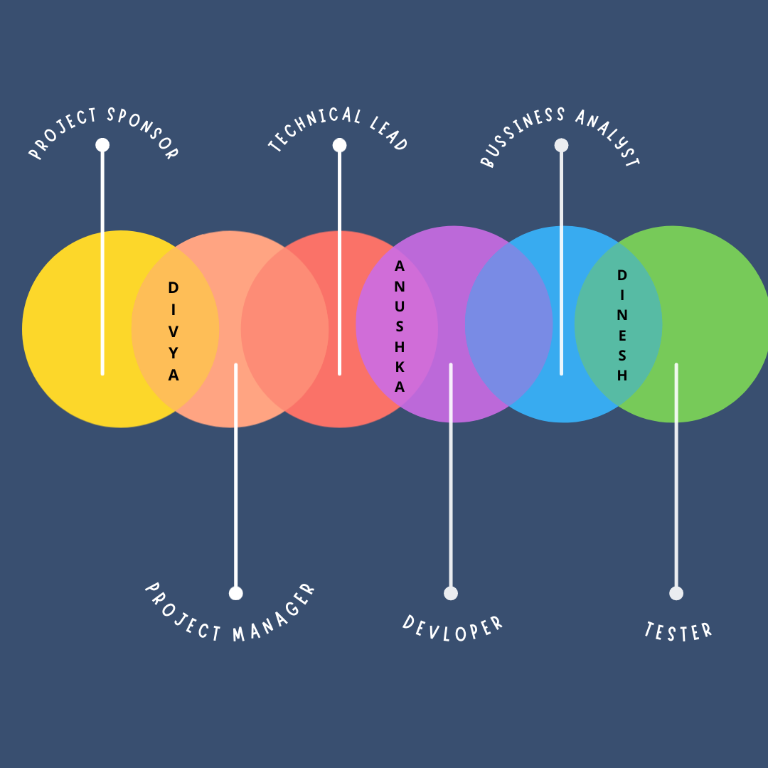

## Roles & Responsibilities

|  |  |  |
| --- | --- | --- |
| **Project Role** | **Team members** | **Responsibilities** |
| Project Sponsor | Divya S Gupta | Identifies and defines the project, can cancel if no longer meets the need. |
| Project Manager | Divya S Gupta | manages proper flow of project |
| Technical Lead | Anushka | manages technical aspects of software development |
| Business Analyst | Dinesh | determine, design and analysis business model |
| Developer | Anushka | modify and implement efficient code |
| Tester | Dinesh | Validates the software in different milestone phases. |

# Reference

1. <https://www.projectmanagement.com/>

**Result-**

Thus, the business case was prepared and the problem statement was arrived

**Experiment 2: Identification of Project Methodology and Stakeholder Description template**

**Aim**

To identify the appropriate Process Model for the project and prepare Stakeholder and User Description.

**Table of Contents**

***1.*** ***Executive Summary***

***2.*** ***Selection of Methodology***

**2.1. Roles and Methods**

***3.*** ***Stakeholder Management***

**3.1. Identification of Stakeholders**

**3.2. Interest and Influence matrix**

**3.3. Communication Plan for Stakeholders**

[***Reference***](https://docs.google.com/document/d/1fPhbSngwoyQv-vJQvk3D0JeclWOpqJK8/edit#heading=h.2s8eyo1)

# Executive Summary

This project follows the Waterfall model methodology as it is a small project with proper understandable requirements. We have used ‘Brainstorming’ elicitation technique for Stakeholder identification and analysis.

# Selection of Methodology

Waterfall model is easy to understand and use. Each phase must be completed before the next phase begins i.e. no overlapping in the phases. Testing begins only after the development is complete.

The steps that are involved in Waterfall methodology:

* *Requirement Analysis*: Requirements are collected and constraints and dependencies are analysed. Goals are set.
* *Scheduling tracking:* Progress of the project is tracked, supervising if the activities are strictly adhering to the schedule/plan.
* *System and Software Design:* System architecture is designed along with fundamental system abstractions and their relationships.
* *Integration and system testing:* Individual modules are integrated and tested as a complete system to ensure that software requirements are met. Software is delivered to the customer.
* *Operation and Maintenance:* The system is put into practical use. Errors that were not identified at the earlier stages are rectified.

**fig-1**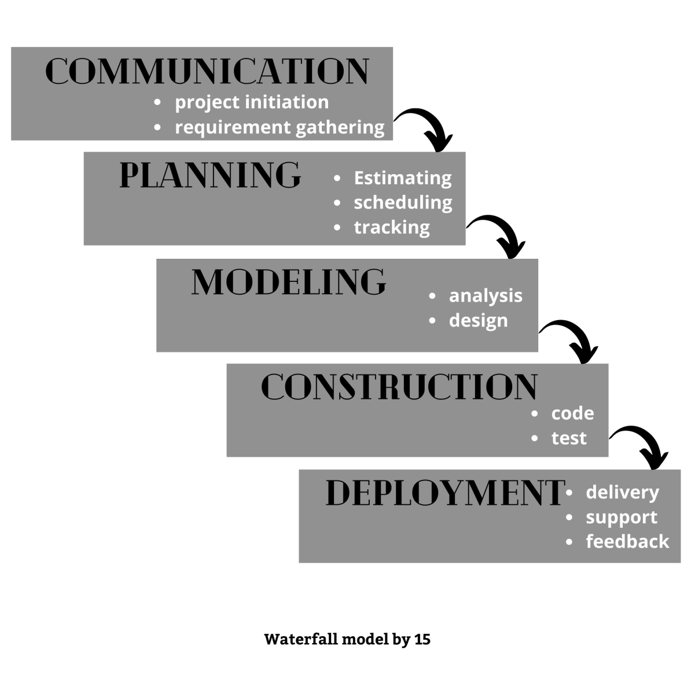

## Roles and Methods

## Brainstorming method was used to identify the stakeholders:

1. Project Manager
2. Team
3. Tester
4. Customer
5. Investor
6. Sponsor
7. Public
8. Evaluator

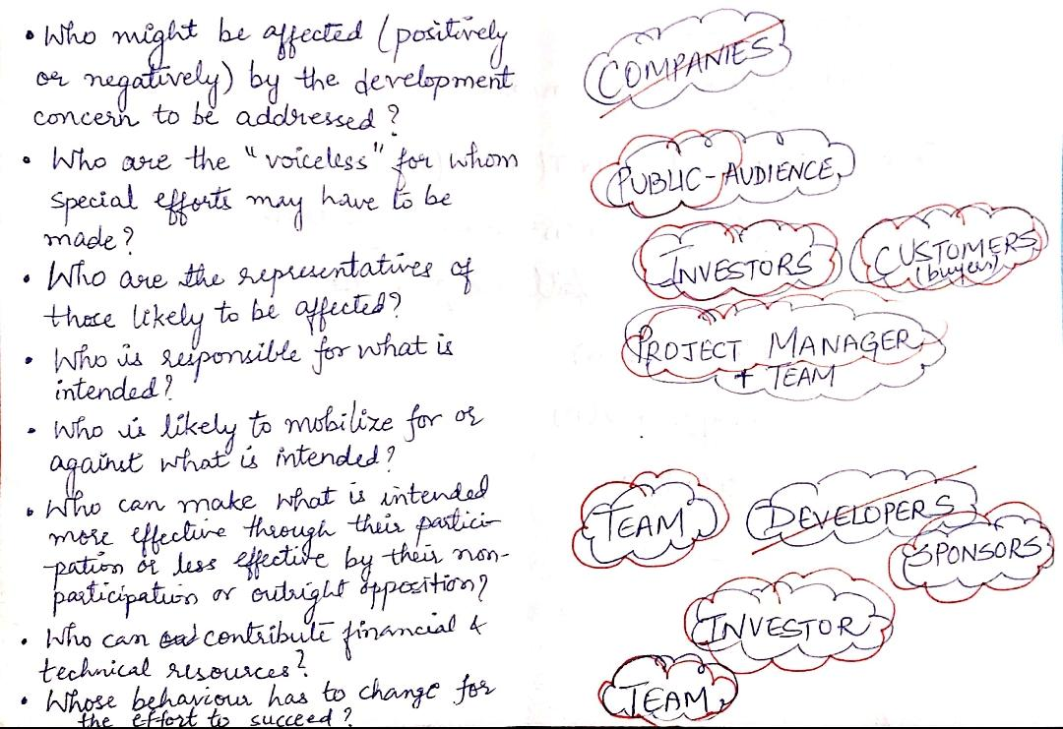

**fig-2**

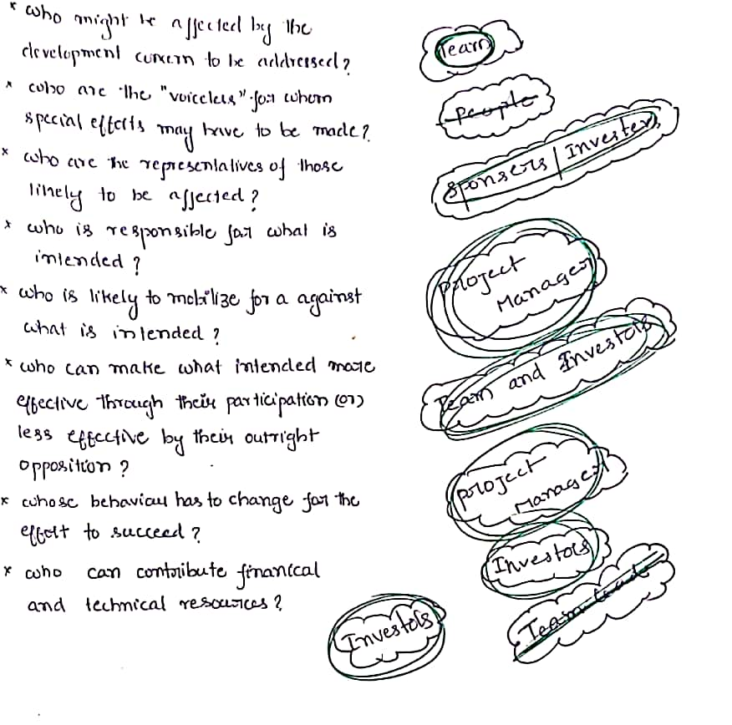

**fig-3**

# Stakeholder Management

## Identification of Stakeholders

1. Project Manager: makes sure the project is ready and delivered on time, manages the whole team and makes sure smooth execution takes place at each phase .

*Interest*- completing the project on time successfully.

1. Team: developing an efficient, bug free code with good accuracy percentage

*Interest*- Profit, experience, recognition

1. Tester: testing and debugging the code for optimum performance of the application

*Interest*-validates the project.

1. Customer: The end-users who buy the product.

*Interest-* To enhance the safety of people.

1. Investor: Invests on the project

*Interest*- to make profit

1. Sponsor: Sponsors the project

*Interest*- To seek reputation.

1. Public: Audience who gives the feedback

*Interest*- Satisfaction

1. Evaluator: Evaluates the final output of this project

*Interest*- Verifying the documentation and objectives of the project

## Interest and Influence matrix

|  |  |
| --- | --- |
| **Interest** | **Influence** |
| High | High |
| Low | Low |
| Low | High |
| High | Low |

|  |  |
| --- | --- |
| **Low Interest, High Influence**  Keep them satisfied as they can be ‘defenders’  Help them engage more | **High Interest, High Influence**  Engage them closely as they are key ‘drivers’ |
| **Low Interest, Low Influence**  Low Priority as they are ‘spectators’ | **High Interest, Low Influence**  Keep them informed as they can be ‘blockers’ |

|  |  |  |  |  |
| --- | --- | --- | --- | --- |
| **Stakeholder Name** | **Activity / Area / Phase** | **Interest** | **Influence** | **Priority (High 1/ Medium 2/Low 3)** |
| Project manager | Manages the team and ensures smooth execution of the phases involved in the project. | High | High | 1 |
| Team | Works on the implementation of the project. | High | High | 1 |
| Tester | Tests, debugs and validates the code required for the project. | high | high | 1 |
| Customer | The end-users who buy the product | high | low | 1 |
| Investor | Invests on the project | high | high | 1 |
| Sponsor | Sponsors our project | low | high | 2 |
| Public | Gives feedback | low | low | 3 |
| Evaluator | Evaluating the project | low | high | 2 |

## Communication Plan for Stakeholders

* Online chat rooms and video calls for the team with Project manager.
* Weekly reports for the low interest and high influence.
* Walk through progress to High Interest and High Influence stakeholders in meetings.
* Bi-Weekly report for High Interest and Low Influence

# Reference

1. <https://www.pmi.org/learning/library/stakeholder-analysis-pivotal-practice-projects-8905>

Result

Thus the Project Methodology was identified and stakeholders were described.

**Experiment 3: Identify/collect the Requirements and document them as Infrastructure Requirements, Functional Requirements and Non-Functional Requirements**

**Aim**

To Identify and document the Requirements of a Software system

**Table of Contents**

***1.*** ***Executive Summary***

***2.*** ***Project Scope***

**2.1.** **In Scope**

**2.2.** **Out of Scope**

***3.*** ***Epics [Major Functions]***

***4.*** ***Requirements***

[**4.1.** **Functional Requirements**](https://docs.google.com/document/d/1jLAegktPsgCVGGkkit7P5JJ_3iPUMDNZpJUI8KH2JwY/edit#heading=h.1t3h5sf)

[**4.2.** **Non-Functional Requirements**](https://docs.google.com/document/d/1jLAegktPsgCVGGkkit7P5JJ_3iPUMDNZpJUI8KH2JwY/edit#heading=h.4d34og8)

[**4.3.** **Infrastructure Requirements**](https://docs.google.com/document/d/1jLAegktPsgCVGGkkit7P5JJ_3iPUMDNZpJUI8KH2JwY/edit#heading=h.2s8eyo1)

[***Reference***](https://docs.google.com/document/d/1jLAegktPsgCVGGkkit7P5JJ_3iPUMDNZpJUI8KH2JwY/edit#heading=h.3rdcrjn)

# **1.** **Executive Summary**

In the Face Mask Detection Project we need to deliver a module integrating it with the web camera of the user to detect whether the person is wearing a mask or not, in an efficient way which can be considered to be the scope of the project.

# **2.** **Project Scope**

The scope of the project is to describe what is to be delivered to the user. In our project we are expected to deliver a module integrating it with the web camera of the user to detect whether the person is wearing a mask or not, in an efficient way.

Project scope classified into:

1. In scope : The deliverables which are to be delivered to the user are involved.
2. Out of scope : The deliverables which are not delivered to the client necessarily.

|  |  |  |
| --- | --- | --- |
| **S.No** | **Activities In Scope** | **Activities Out of Scope** |
| 1. | To deliver the system which could detect whether the person is wearing a face mask using different datasets. | To integrate this system with the camera in the public areas to have supervision on the people whether they are wearing masks or not. |
| 2. |  | To find out the people who are actually not wearing masks amid a large group of people as CCTV captures many faces and the algorithm may not be able to detect one. |
| 3. |  | Places like local markets wherein people cannot afford to have a CCTV camera installed. |

**2.1. In Scope**

Activities that are going to be delivered through our project enables the user to check whether one is wearing a face mask through one’s web camera or the public cctv cameras.

## **2.2.** **Out of Scope**

The activities which are not going to be delivered are said to be out of scope.

* In our project, Integrating Face mask detection system with CCTV cameras is difficult.
* To find out the people who are actually not wearing masks amid a large group of people as CCTV captures many faces and the algorithm may not be able to detect one.
* Places like local markets wherein people cannot afford to have a CCTV camera installed.

# 

# 

# 

# **3.** **Epics [Major Functions]**

|  |  |
| --- | --- |
| **Epic (#)** | **Epic Description** |
| E1 | Detecting the fask mask through the web/public cameras using efficient dependencies. |

**4. Requirements**

**4.1. Functional Requirements**

|  |  |  |  |  |
| --- | --- | --- | --- | --- |
| **Requirement (#)** | **Requirement Specification** | **Department** | **Name of Business User** | **Status** |
| E1FR1 | As a customer, To detect whether a person is wearing a mask or not. |  |  |  |

**4.2. Non-Functional Requirements**

|  |  |  |  |  |  |
| --- | --- | --- | --- | --- | --- |
| **Requirement (#)** | **Category of NFR** | **Requirement Specification** | **Department** | **Name of Business User** | **Status** |
| NFR2 | Performance | Spontaneous identification that a person is wearing a mask or not. |  |  |  |
|  | Availability | It can be made available 24/7. |  |  |  |
|  | Scalability | It can supervise only one person at a time. |  |  |  |
| E1NFR2 | Usability | It can be used till it gets outdated. |  |  |  |
|  | Traceability | There is no room for traceability as we are following the Waterfall model. |  |  |  |
|  | Flexibility | No flexibility |  |  |  |
| E1NFR1 | Extensibility | Yes |  |  |  |
|  | Interoperability | Can connect and exchange information with CCTV computational systems by giving access, without restriction. |  |  |  |
|  | Reliability | depends on the quality of the camera, and system specifications |  |  |  |

**4.3. Infrastructure Requirements**

|  |  |  |  |  |
| --- | --- | --- | --- | --- |
| **Requirement (#)** | **Requirement Specification** | **Department** | **Name of Business User / Project Team Member** | **Status** |
| IR1 | Laptop/Computer with accessible web camera. |  |  |  |
| IR2 | Latest versions of CPU, GPU and RAM |  |  |  |

**Reference**

1. <https://www.pmi.org/>
2. <https://www.atlassian.com/agile/project-management/user-stories>

**Result:**

Thus, the requirements are identified, collected and documented.

**Experiment 4 : To prepare project plan**

**Aim**

To Prepare Project Plan based on scope, Find Job roles and responsibilities, Calculate Project effort based on resources

**Table of Contents**

[***1.*** ***Executive Summary***](https://docs.google.com/document/d/1KWD-kLs_Rma73nC5kdC2QDzIrF3PBBYx3cL2FpdWQKU/edit#heading=h.gjdgxs)

[***2.*** ***Project Management Plan***](https://docs.google.com/document/d/1KWD-kLs_Rma73nC5kdC2QDzIrF3PBBYx3cL2FpdWQKU/edit#heading=h.30j0zll)

[***3.*** ***Estimation***](https://docs.google.com/document/d/1KWD-kLs_Rma73nC5kdC2QDzIrF3PBBYx3cL2FpdWQKU/edit#heading=h.1fob9te)

[***3.1.*** ***Effort and Cost Estimation***](https://docs.google.com/document/d/1KWD-kLs_Rma73nC5kdC2QDzIrF3PBBYx3cL2FpdWQKU/edit#heading=h.3znysh7)

[***3.2.*** ***Infrastructure/Resource Cost [CapEx]***](https://docs.google.com/document/d/1KWD-kLs_Rma73nC5kdC2QDzIrF3PBBYx3cL2FpdWQKU/edit#heading=h.2et92p0)

[***4.*** ***Maintenance and Support Cost [OpEx]***](https://docs.google.com/document/d/1KWD-kLs_Rma73nC5kdC2QDzIrF3PBBYx3cL2FpdWQKU/edit#heading=h.tyjcwt)

[***5.*** ***Project Team Formation***](https://docs.google.com/document/d/1KWD-kLs_Rma73nC5kdC2QDzIrF3PBBYx3cL2FpdWQKU/edit#heading=h.3dy6vkm)

[***5.1.*** ***Identification Team members***](https://docs.google.com/document/d/1KWD-kLs_Rma73nC5kdC2QDzIrF3PBBYx3cL2FpdWQKU/edit#heading=h.1t3h5sf)

[***5.2.*** ***Responsibility Assignment Matrix***](https://docs.google.com/document/d/1KWD-kLs_Rma73nC5kdC2QDzIrF3PBBYx3cL2FpdWQKU/edit#heading=h.4d34og8)

[***Reference***](https://docs.google.com/document/d/1KWD-kLs_Rma73nC5kdC2QDzIrF3PBBYx3cL2FpdWQKU/edit#heading=h.2s8eyo1)

# Executive Summary

The scope of the project is to enhance the safety of people in crowded areas as well as to reduce the risk of getting infected by the pandemic, also reducing human resources and time.

We have followed the COCOMO Model for cost estimation and it is estimated to be around INR 7,50,000. We took up ‘Brainstorming’ elicitation for estimating the requirements. The team requires the following skills:

* ML developing skills
* UI/UX designing skills

# Project Management Plan

It outlines the scope, goals, budget, timeline, and deliverables of a **project**, and it's essential for keeping a **project** on track.

|  |  |
| --- | --- |
| **Focus Area** | **Details** |
| Integration Management | * WaterFall model is used for this project. * Project is managed by the team lead. Testing and developing done by team members. * Documentation is prepared by the whole team * there is no change in this project and requirement . * Project will be delivered by 20 April 2021 |
| Scope Management | * The main scope of the project is to detect whether a person is wearing a mask or not. * We are gathering our requirements through a technique called brainstorming. We are calculating the cost and effort estimations based on the requirement of the user. * The Deliverable which is delivered to the end user is to provide a module to detect the face mask of a person. |
| Schedule Management |  |
| Cost Management | Using COCOMO model   * Effort is estimated to be 13 Person month * One time investment Rs 3,50,000 * Operational investment Rs 4,00,000 |
| Resource Management | * Estimation is done by ‘Brainstorming’ * People: Team, ML developers, Tester,UI/UX designers * Finance: Budget-RS. 7,50,000 * Physical: Laptop,printer,webcam. |
| Stakeholder | * Stakeholder analysis is done by ‘Brainstorming’ elicitation. * The stakeholders include investors, sponsor, team, project manager, tester, customer, public, evaluator. * Weekly meetings would be organised with the team and the stakeholders. * Bi-weekly reports are to be maintained. |
| Communication Management | * Project manager has to be informed about the progress of the project. * Online chat rooms and video calls for the team with Project manager. * Weekly reports for the low interest and high influence. * Walk through of progress to High Interest and High Influence stakeholders in meeting. * Bi-Weekly report for High Interest and Low Influence . |
| Risk Management |  |

# Estimation

# Effort and Cost Estimation :

|  |  |  |  |  |  |  |
| --- | --- | --- | --- | --- | --- | --- |
| **WBS** | **Activity** | **Activity Description** | **Sub-Task** | **Sub-Task Description** | **Effort (in hours)** | **Cost in INR** |
| E1FR1 | E1R1A1 | Collecting datasets | E1R1A1T1 | Collecting dataset of images with and without masks | 5 | 1,00,000 |
| E2FR2 | E2R2A2 | Training the datasets | E2R2A2T2 | Processing the data | 5 | 1,00,000 |
| E3FR3 | E3R3A3 | Implementation of the algorithm | E3R3A3T3 | Adding functionalities to detect masks using trained data sets. | 6 | 1,00,000 |
| E4FR4 | E4R4A4 | Testing | E4R4A4T4 | Testing and debugging | 3 | 50,000 |

|  |  |
| --- | --- |
| **Total Effort (hr)** | **Total Cost (INR)** |
| 19 | 3,50,000 |

# Infrastructure/Resource Cost [CapEx]

|  |  |  |  |
| --- | --- | --- | --- |
| **Infrastructure Requirement** | **Qty** | **Cost per qty** | **Cost per item** |
| IR1 Hardware- printer | 1 | 25,000 | 25,000 |
| IR2 Web camera | 4 | 10,000 | 40,000 |

Total Infrastructural Cost : 65,000/-

# Maintenance and Support Cost [OpEx]

|  |  |  |  |  |
| --- | --- | --- | --- | --- |
| **Category** | **Details** | **Qty** | **Cost per qty per month** | **Cost per item** |
| People | Network, System,  Developer , Consultant | 3 | 56,000 | 1,67,500 |
| Infrastructures | Server, Storage, Datasets and Network | 20 | 8,400 | 1,67,500 |

Total Maintenance and Support Cost = INR 3,35,000

# Project Team Formation :

# Identification Team members

|  |  |  |
| --- | --- | --- |
| **Name** | **Role** | **Responsibilities** |
| Divya S Gupta | Key Business User (Product Owner) | Provide clear business and user requirements |
| Divya S Gupta | Project Manager | Manage the project |
| Dinesh | Business Analyst | Discuss and Document Requirements |
| Anushka | Technical Lead | Design the end-to-end architecture |
| Dinesh, Anushka | ML Developers | Training the datasets and implementing the algorithm |
| Dinesh | Tester | Define Test Cases and Perform Testing |

# Responsibility Assignment Matrix :

|  |  |  |  |  |  |  |  |
| --- | --- | --- | --- | --- | --- | --- | --- |
| **RACI Matrix** | **Team Members** | | | | | |  |
| **Activity** | **Name (Business Analyst)** | **Dinesh(Developer) and Anushka (Developer)** | **Dinesh(Tester)** | **Divya S Gupta (Project Manager)** | **Senior Stakeholders** | **Key Business User** | **Company** |
| User Requirement Documentation | A | C/I | I | I | C/I | R | R |
| Providing vision and goal for the product | A | C/I | I | A/R | C/I | A/R | R |
| Providing resources with the right skills and mind set | A | A | I | I | C | A | R |
| Prioritizing functional and technical requirements | A | C/I | I | C/I | C/I | C/I | R |
| Managing risks | A | A/R | I | I | I | A | R |
| Ensuring quality of the product | C | A | I | A/R | C/I | A/R | R |
| Testing and debugging | C | I | A/R | I | C | A | R |
| Decide on release date and goal (Delivery roadmap) | R | C/I | C/I | R/A | C | A | R |

|  |  |
| --- | --- |
| A | Accountable |
| R | Responsible |
| C | Consult |
| I | Inform |

# Reference

1. <https://www.pmi.org/>
2. <https://www.projectmanagement.com/>
3. <https://www.tpsgc-pwgsc.gc.ca/biens-property/sngp-npms/ti-it/ervcpgpm-dsfvpmpt-eng.html>

Result:

Thus, the Project Plan was documented successfully.

**Experiment 5 : To prepare work, breakdown structure, risk identification and plan**

**Aim**

To Prepare the Work, Breakdown Structure based on timelines, Risk Identification and Plan

**Table of Contents**

***1.*** ***Executive Summary***

***2.*** ***WBS*** ***With*** ***Project Schedule***

***3.*** ***Risk Identification***

**3.1.** **List (Describe) Register**

[**3.2.** **Managing Risk**](https://docs.google.com/document/d/1P_8XbFJDLo2oqE4Bl8qTSir_kDzbUEzk_cMBJbEUrgE/edit#heading=h.1t3h5sf)

***Reference***

# Executive Summary

**Summarization of Milestones :**

A milestone is a specific point of time within a project lifecycle used to measure the progress of a project toward its end goal.

Here are the few Milestones for our project:

**Initialization of the project :**

Develop a model of how it works, and get to know about the dependencies and proceed

with the installations

**Processing Datasets :**

Collecting the data sets from different source files (with and without mask)

**Training the Datasets :**

Data processing: Converting all the images to arrays, to create a deep learning model.

After processing the images to arrays, they are sent to mobile net, forms a fully Connected

layer and get the output

**Testing/Improvement :**

Debugging the code and QA testing documentation.Conducting technical reviews and implementing user acceptance testing.

**Target Date** is scheduled based on Milestones,so depending upon the milestones we have the target date is fixed to **20 April**.

**Risk Management** is identifying the risk faced in the project and we are trying to identify the risk faced from both sides of the project and also trying to make it much more efficient.

# WBS With Project Schedule

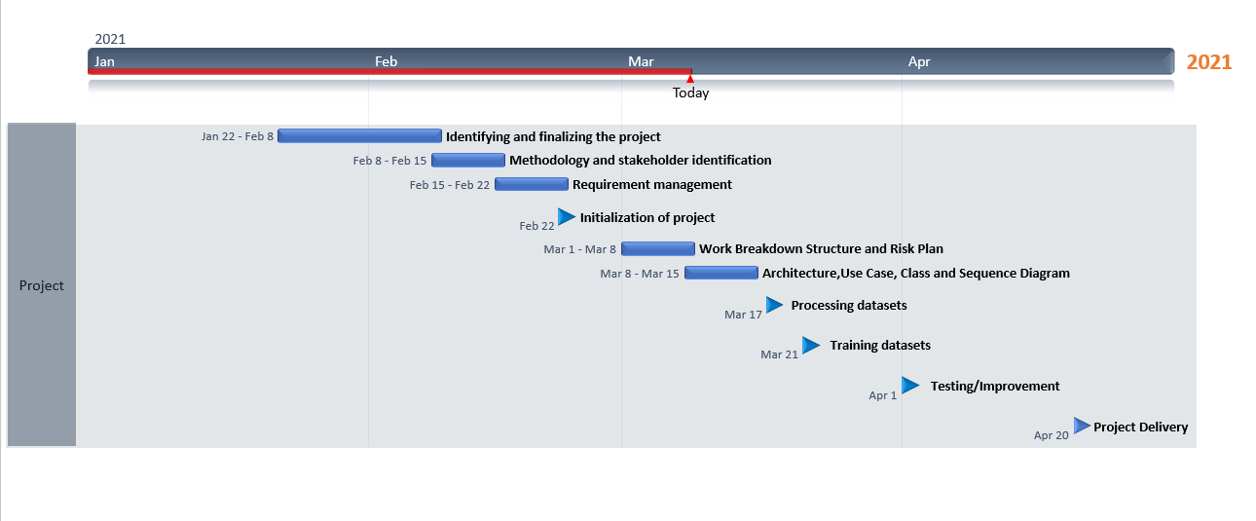

# Risk Identification

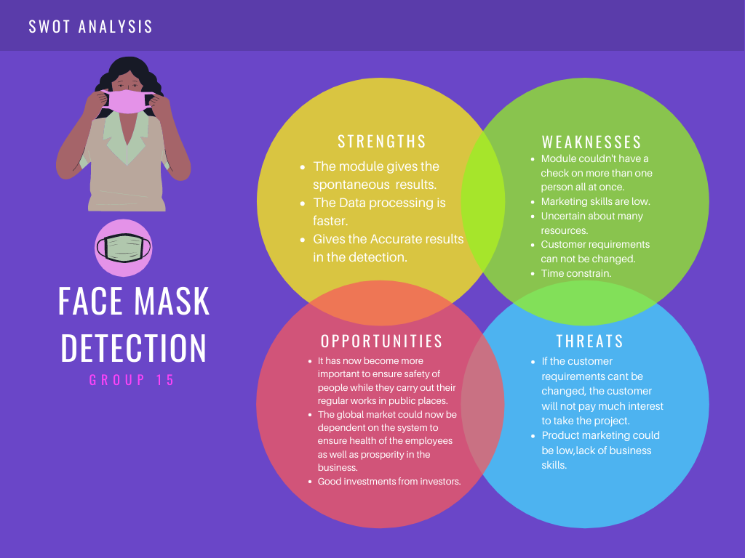

Swot analysis is a very useful framework for analyzing an organization's strengths, weaknesses , opportunities and threats.

**Strengths :**

*The module gives spontaneous results.

*The Data processing is faster.

*Gives the Accurate results in the detection.

**Weakness :**

*Module couldn't have a check on more than one person all at once.

*Marketing skills are low.

*Uncertain about many resources.

*Customer requirements can not be changed.

*Time constraint.

**Threats :**

*If the customer requirements cant be changed, the customer will not pay much interest to take the project.

*Product marketing could be low, lack of business skills.

**Opportunities:**

* It has now become more important to ensure the safety of people while they carry out their regular works in public places.

* The global market could now be dependent on the system to ensure health of the employees as well as prosperity in the business.

* Good investments from investors.

## List (Describe) Register

|  |  |  |
| --- | --- | --- |
| **Risk ID (#)** | **Risk Description** | **Impact Description** |
| R01 | Bad quality of CCTV Cameras | Captured poor resolution images which would affect the face mask detection system. |
| R02 | Lighting effects | Poor lighting effects would lead to poor detection of people with or without face masks. |
| R03 | images captured in a motion | Images captured while people run can lead to failure of mask detection. |

## Managing Risk

|  |  |  |  |  |  |  |
| --- | --- | --- | --- | --- | --- | --- |
| **Risk ID (#)** | **Status [Open / Closed]** | **Risk Appetite**  **[ Accept/ Mitigate/ Transfer/Avoid]** | **Action** | **Action Owner** | **Target Date** | **Remarks** |
| R01 | Open | Avoid | - | - |  | suggest they have good quality cctv. |
| R02 | Open | Mitigate | Adaptive Brightness Algorithms/better sensors can be Implemented | Developer | takes two months extra time to include these efficient features for Improvement | - |
| R03 | Open | Mitigate | The speed of the video should be adopted automatically to make face mask detection efficient. | Developer | takes one month extra to mitigate this risk. | - |

# Reference

1. https://www.pmi.org/

Result:

Thus, the WBS and Risk Plan was documented successfully.

**Experiment 6 : Design a System Architecture, Use Case Diagram, ER Diagram (Database), DFD Diagram (process) (Upto Level 1), Class Diagram (Applied For OOPS based Project), Sequence Diagram (Applied For OOPS based Project) (Software – Rational Rose)**

**Aim :** To prepare architecture and design of the system.

**Table of Contents**

***1.*** ***Class Diagram***

***2.*** ***Use Case Diagram***

***3.*** ***Collaboration Diagram***

***4.*** ***DFD Diagram***

***5.Architecture Diagram***

**Class diagram:**

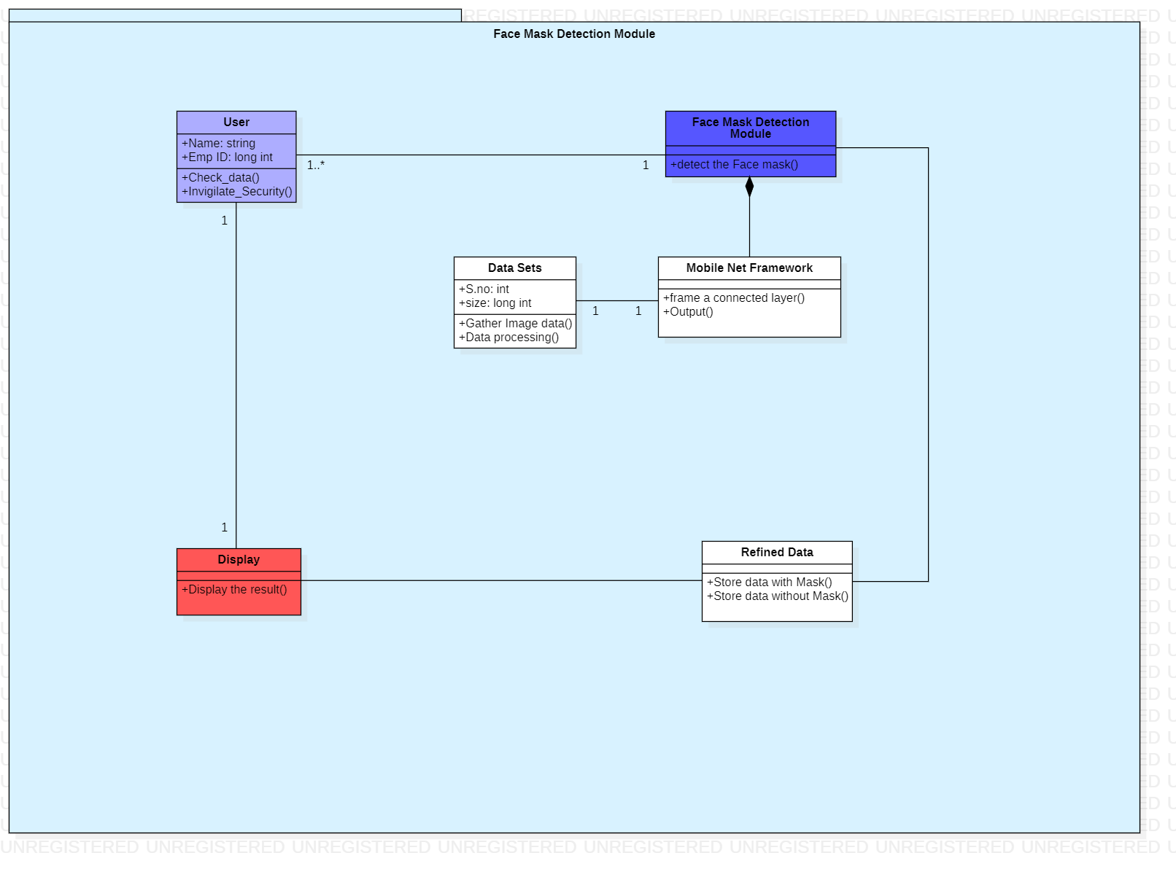

Class diagram describes the attributes and operations of a class. It also describes the constraints imposed on the system. The class diagrams are widely used in the modelling of object-oriented systems because they are the only UML diagrams, which can be mapped directly with object-oriented languages. The above diagram shows 6 classes namely User, Display, Refined Data, Face Mask Detection module, Mobile Net Framework and Datasets along with their relationship to one another. Multiplicity is also mentioned indicating the allowable number of instances of the element in the given relationship.

**Use case diagram:**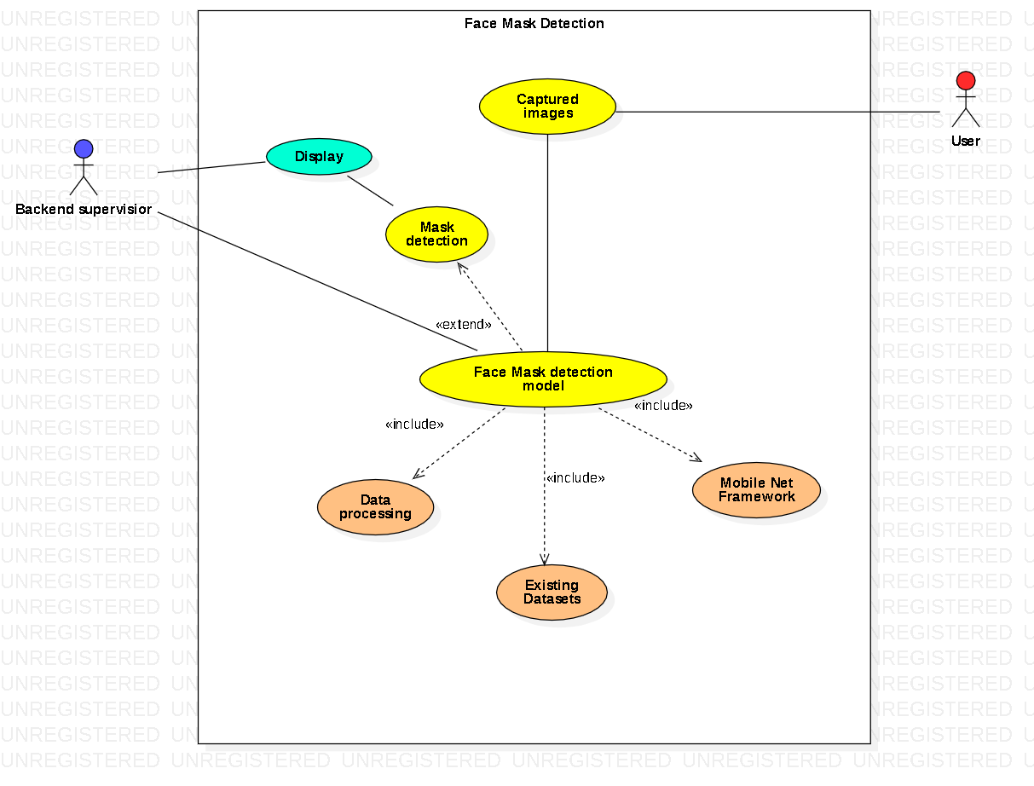A use case diagram is a representation of a user's interaction with the system that shows the relationship between the user and the different use cases in which the user is involved. The diagram above depicts the interaction and use cases of user and backend supervisor.

**Collaboration diagram:**

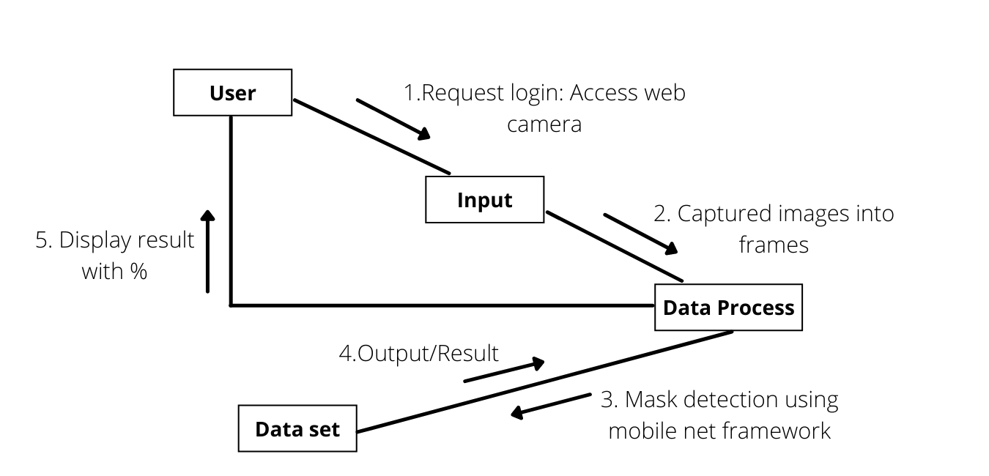

Collaboration diagrams illustrate the relationships and interactions among various software objects. They portray the dynamic behavior of a particular use case and define the role of each object. They are the primary source of information used to determine class responsibilities and interfaces. In the above diagram, interactions between objects like User, Input, Data Process and Data Set are depicted.

**DFD diagram:**

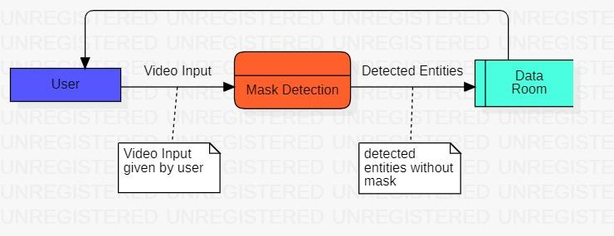

A data-flow diagram is a diagram depicting the flow of data through a process or a system. The DFD basically gives an insight on how the information enters and leaves the system, what changes the information and where information is stored. A data-flow diagram has no control flow and there are no decision rules.

**Architecture:**

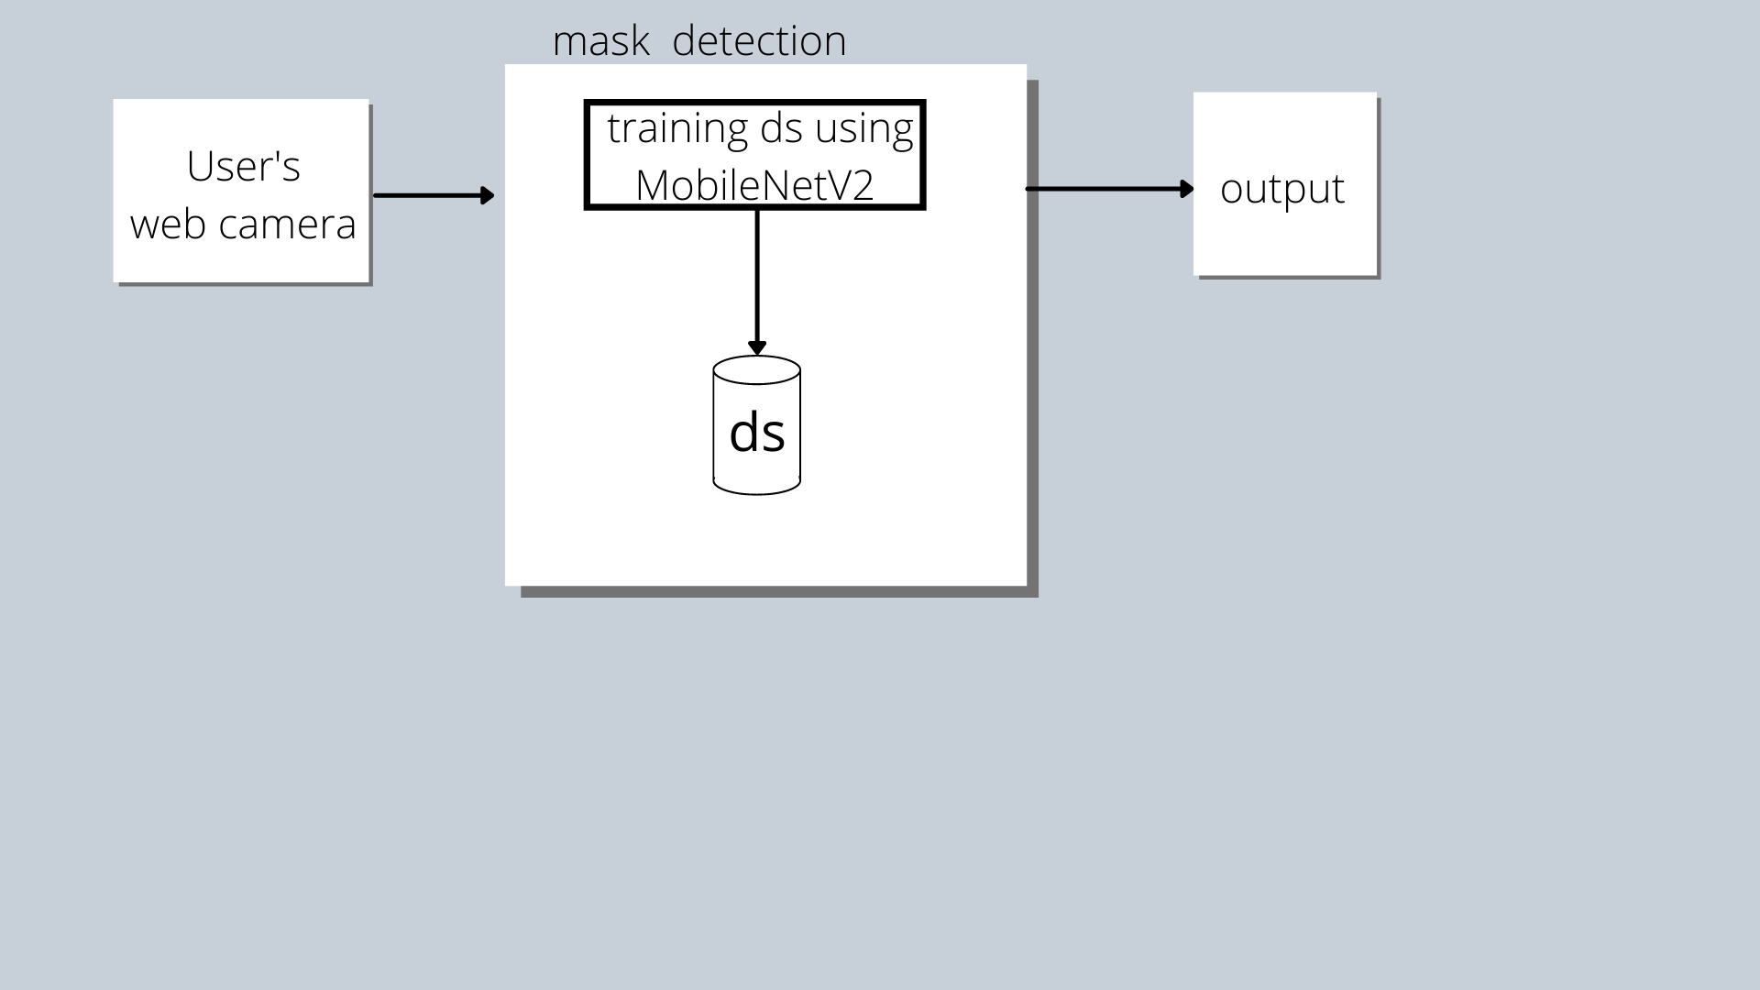

An architectural diagram is a diagram of a system that is used to abstract the overall outline of the software system and the relationships, constraints, and boundaries between components. It is an important tool as it provides an overall view of the physical deployment of the software system and its evolution roadmap.

**Result:**

Thus, architecture and design of the system was documented successfully.

# Reference

1. <https://www.pmi.org/>

**Experiment 7 : Design State , Collaboration, Deployment Diagram, Sample Frontend Design (UI/UX)**

**Aim**

To Design State, Activity, Deployment Diagram, Sample Frontend Design (UI/UX) for the project.

**Table of Contents**

***1.*** ***State Diagram***

***2.*** ***Activity Diagram***

***3.*** ***Deployment Diagram***

***4.*** ***UI/UX Front end design***

**State Diagram:**

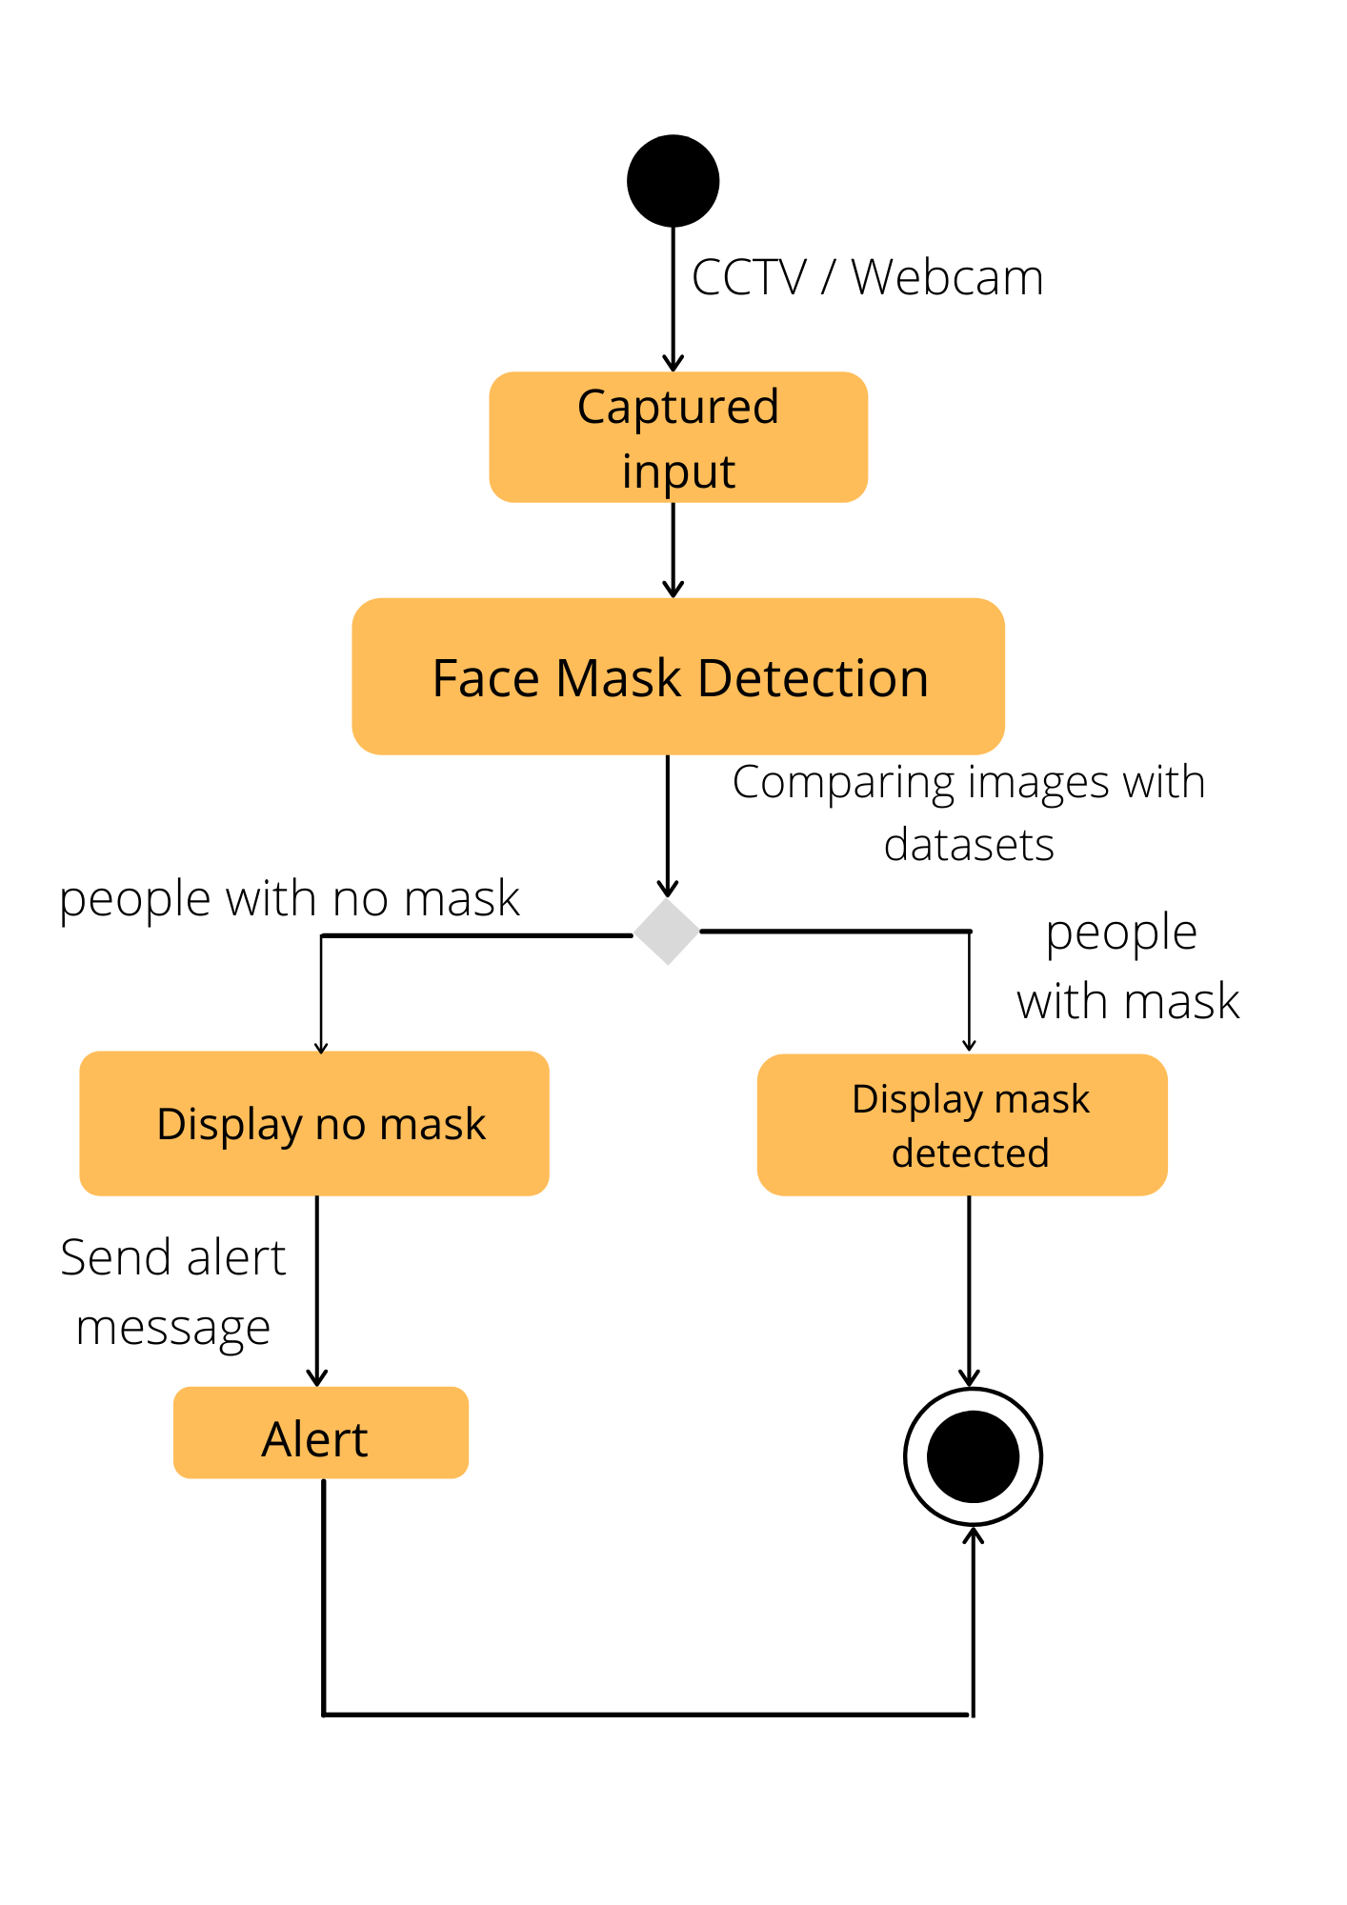

The purpose of state diagrams is to depict the states of a component and these state changes are dynamic in nature. Its specific purpose is to define the state changes triggered by events.

**Activity Diagram:**

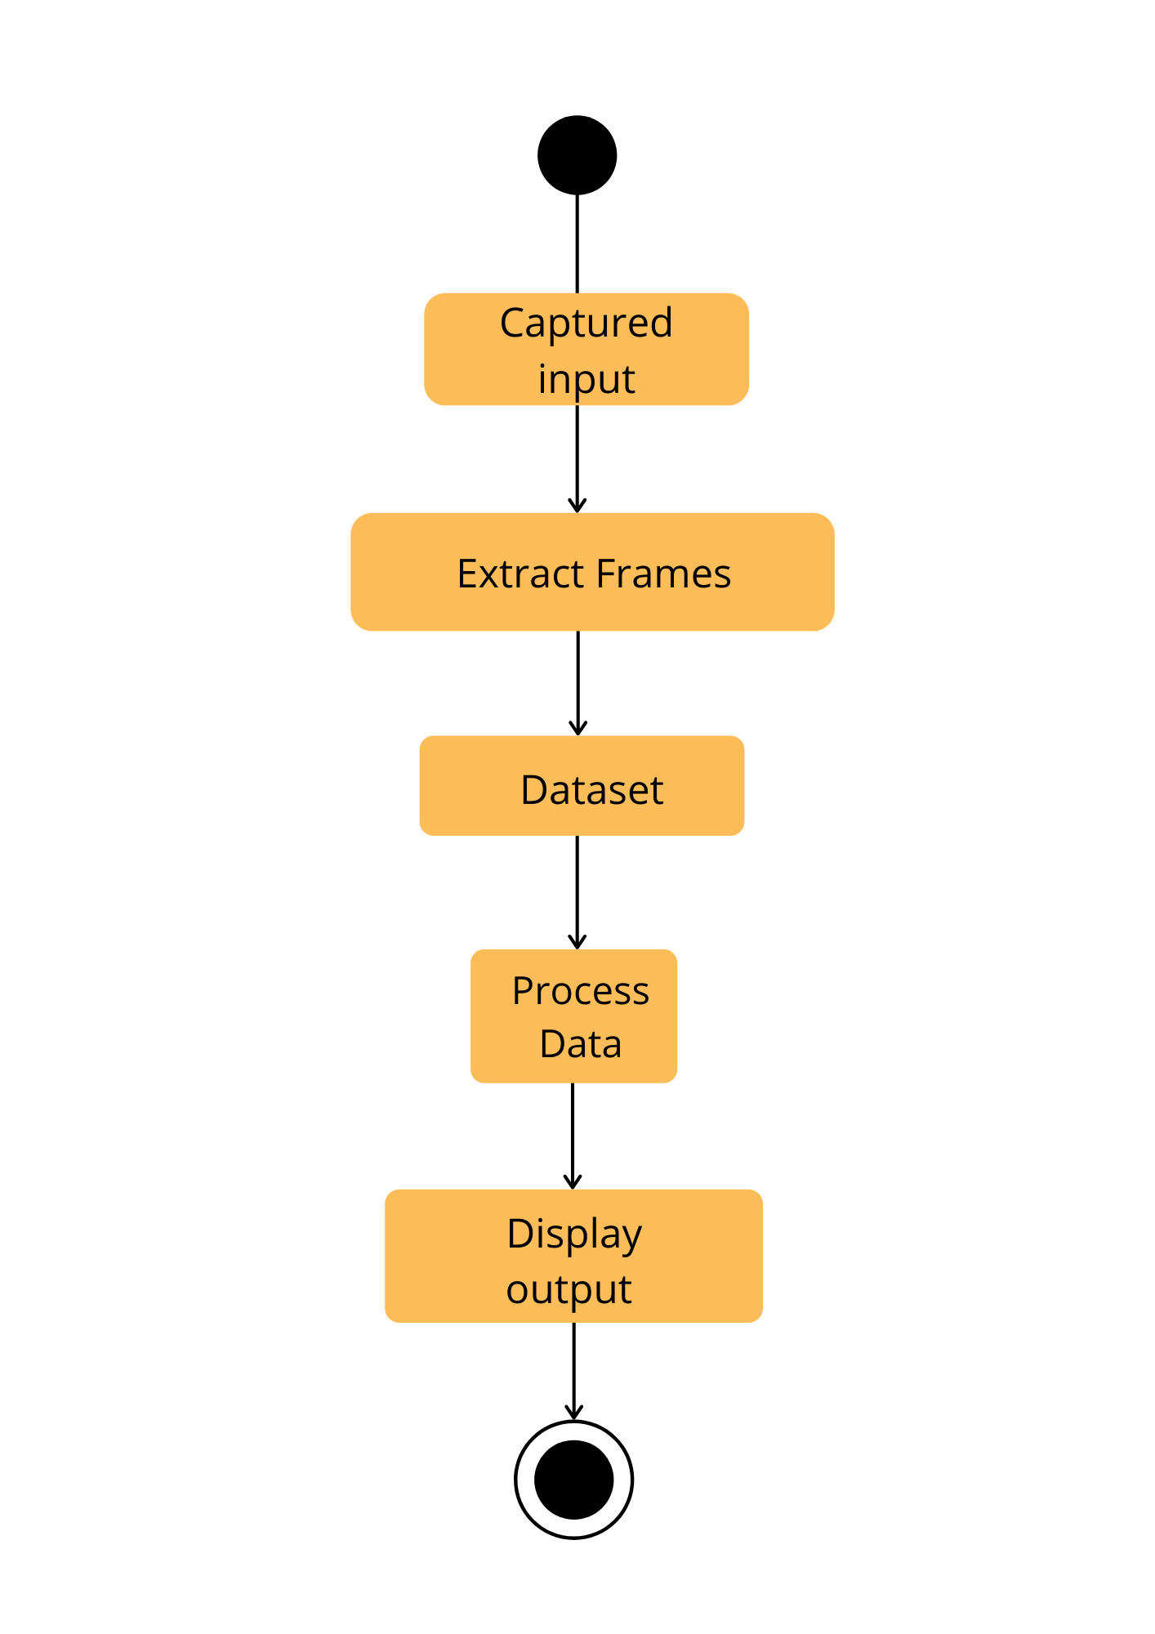

Activity diagram is a behavioural diagram showcasing the behaviour of a system. It portrays control flow from a start point to a finish point showing path during the execution of the program. Here, it portrays the activities involved during the execution of the face mask detection model.

**Deployment diagram:**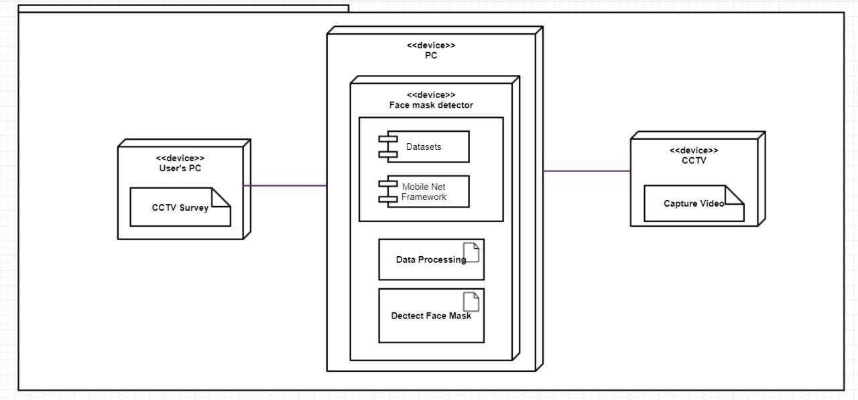

The purpose of our deployment diagram is to display how the Face mask detection Algorithm works and It also explains the way it is deployed on Hardware devices like CCTV, Computer.

Here a few nodes ( devices ) are User, CCTV and PC in which the face mask detection module is installed. and few Artifacts are functioning to complete the Project.

**UI/UX front end design:**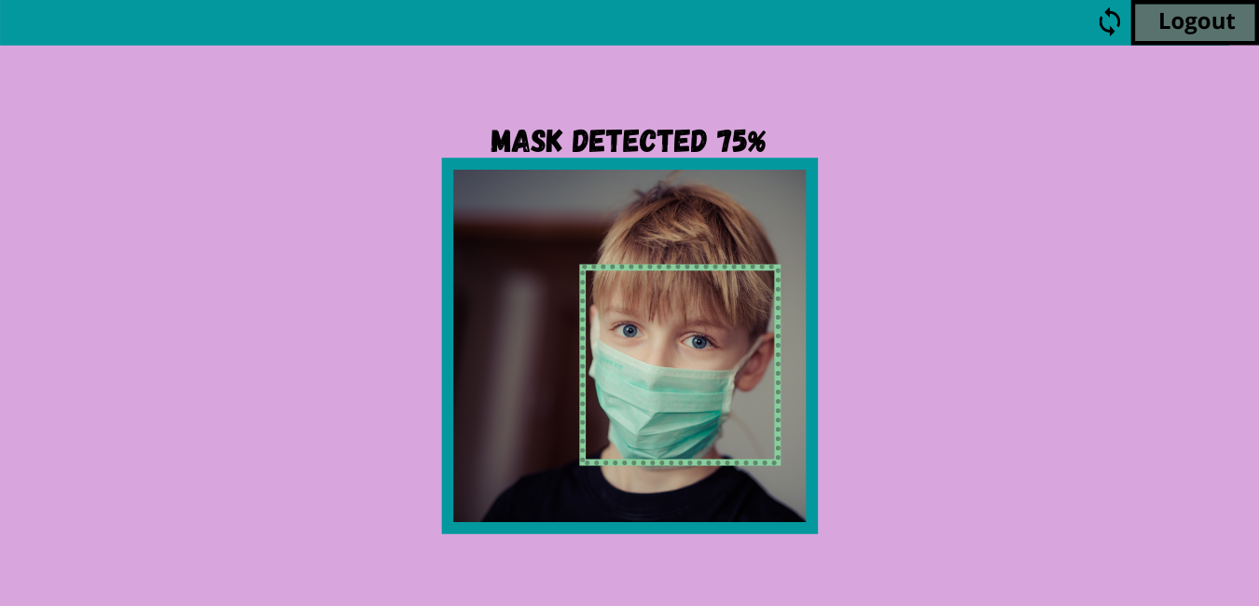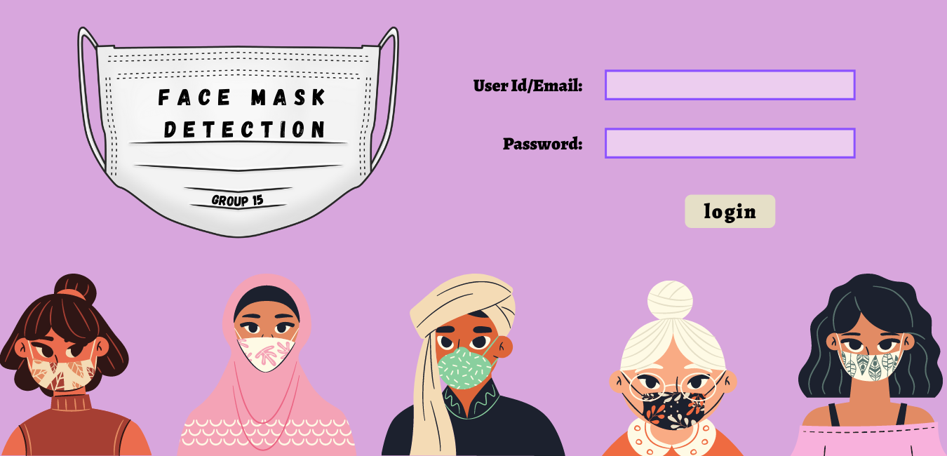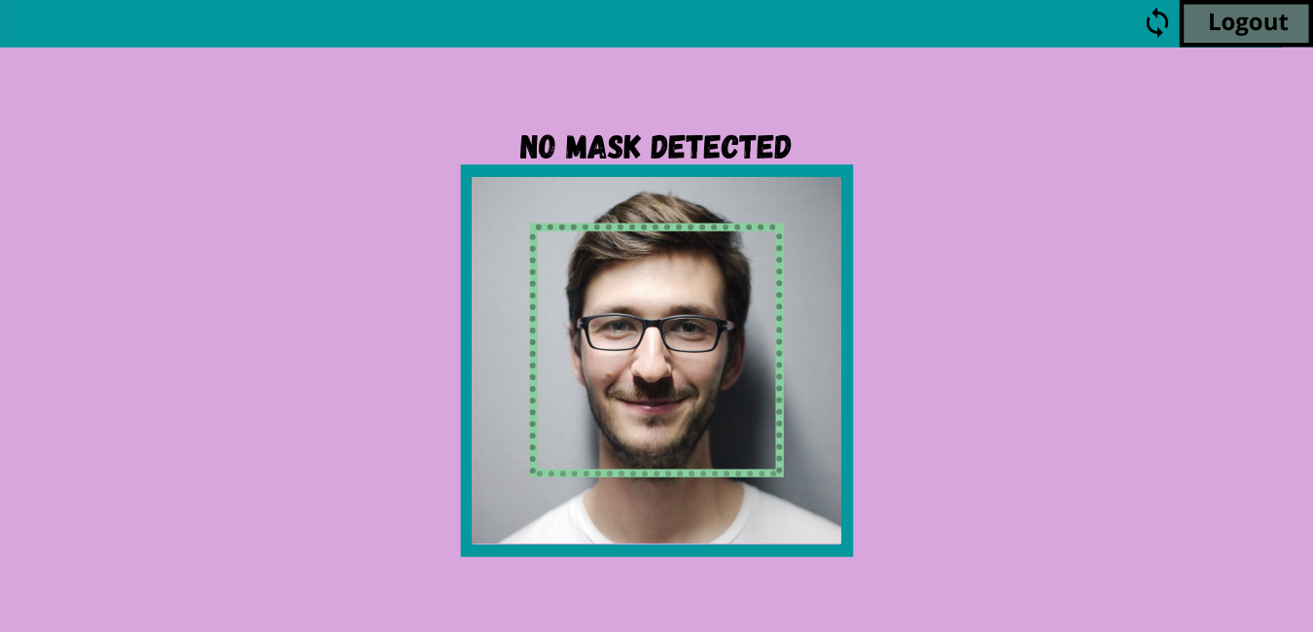

Result:

Thus, above mentioned designs of the system were documented successfully.

**Experiment 8 : Module 1 description and implementation**

**Aim**

To describe modules and implement Module1

**Software Used**

**HTML and CSS**

**Code of Module 1**

**HTML-**

<html>

<head>

<title>Login Form</title>

<link rel="stylesheet" type="text/css" href="css/style.css">

</head>

<body background="C:\Users\gopal\Desktop\gd\Face Mask Detectiontydytd.png">

<h1>Face Mask Detection</h1>

<div class="login">

<form id="login" method="get" action="login.php">

<label><b>User Name

</b>

</label>

<input type="text" name="Uname" id="Uname" placeholder="Username">

<br><br>

<label><b>Password

</b>

</label>

<input type="Password" name="Pass" id="Pass" placeholder="Password">

<br><br>

<input type="button" name="log" id="log" value="Log In Here">

<br><br>

<input type="checkbox" id="check">

<span>Remember me</span>

<br><br>

Forgot <a href="#">Password</a>

</form>

</div>

</body>

</html>

**CSS-**

body

{

margin: 0;

padding: 0;

font-family: 'Arial';

}

.login{

width: 382px;

overflow: hidden;

margin: auto;

margin: 20 0 0 450px;

padding: 25px;

border-radius: 15px ;

}

h1{

text-align: center;

color: black;

padding: 28px;

}

label{

color: #08ffd1;

font-size: 17px;

}

#Uname{

width: 300px;

height: 30px;

border: none;

border-radius: 3px;

padding-left: 8px;

}

#Pass{

width: 300px;

height: 30px;

border: none;

border-radius: 3px;

padding-left: 8px;

}

#log{

width: 300px;

height: 30px;

border: none;

border-radius: 17px;

padding-left: 7px;

color: brown;

}

span{

color: white;

font-size: 17px;

}

a{

float: right;

background-color: grey;

}

**Result of Module 1**

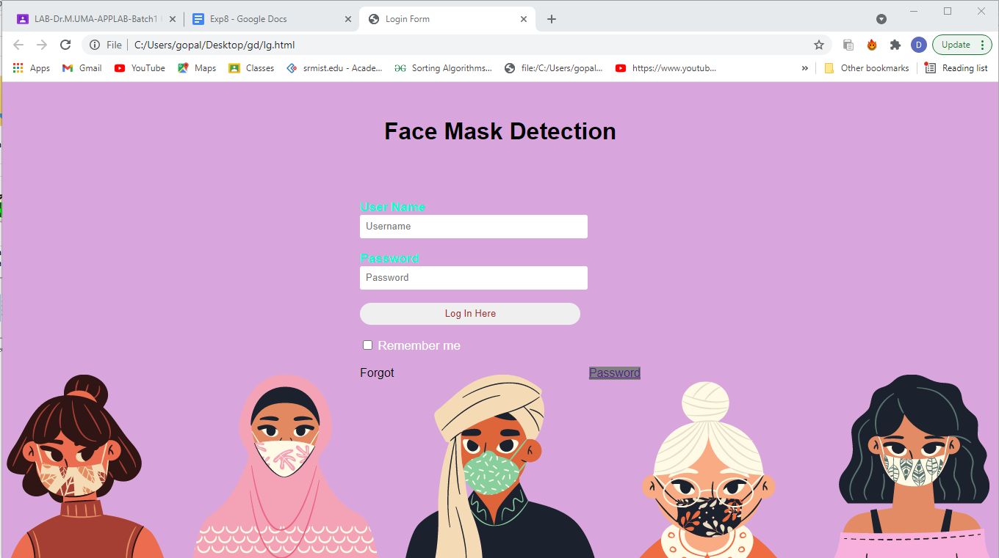

**Result:**

Thus, modules are described, Module 1 was implemented and documented successfully.

**Experiment 9 : Module 2 description and implementation**

**Aim**

To implement Module 2 of the project and display the output of the module with new requirements may assimilated

**Software Used**

**Python**

**Code of Module 2**

!pip install -U retinaface_pytorch > /dev/null

!pip install facemask_detection > /dev/null

!wget -O crowd.jpg https://static.toiimg.com/thumb/msid-79703188,imgsize-713774,width-400,resizemode-4/79703188.jpg > /dev/null

import cv2

import albumentations as A

import torch

import numpy as np

from tqdm import tqdm

from matplotlib import pyplot as plt

from retinaface.pre_trained_models import get_model as get_detector

from facemask_detection.pre_trained_models import get_model as get_classifier

plt.rcParams["figure.figsize"] = (15, 15)

image = cv2.imread("crowd.jpg")

image = cv2.cvtColor(image, cv2.COLOR_BGR2RGB)

plt.imshow(image)

face_detector = get_detector("resnet50_2020-07-20", max_size=800)

face_detector.eval()

with torch.no_grad():

annotations = face_detector.predict_jsons(image)

len(annotations)

print(annotations)

mask_classifier = get_classifier("tf_efficientnet_b0_ns_2020-07-29")

mask_classifier.eval();

transform = A.Compose([A.SmallestMaxSize(max_size=256, p=1),

A.CenterCrop(height=224, width=224, p=1),

A.Normalize(p=1)])

predictions = []

with torch.no_grad():

for annotation in tqdm(annotations):

x_min, y_min, x_max, y_max = annotation['bbox']

x_min = np.clip(x_min, 0, x_max)

y_min = np.clip(y_min, 0, y_max)

crop = image[y_min:y_max, x_min:x_max]

crop_transformed = transform(image=crop)['image']

model_input = torch.from_numpy(np.transpose(crop_transformed, (2, 0, 1)))

predictions += [mask_classifier(model_input.unsqueeze(0))[0].item()]

vis_image = image.copy()

for prediction_id, annotation in enumerate(annotations):

is_mask = predictions[prediction_id] > 0.5

if is_mask:

color = (0, 255, 0)

text = "mask"

else:

color = (255, 0, 0)

text = "no mask"

x_min, y_min, x_max, y_max = annotation["bbox"]

x_min = np.clip(x_min, 0, x_max - 1)

y_min = np.clip(y_min, 0, y_max - 1)

vis_image = cv2.rectangle(vis_image, (x_min, y_min), (x_max, y_max), color=color, thickness=2)

vis_image = cv2.putText(vis_image, text, (x_min, y_min - 10), cv2.FONT_HERSHEY_SIMPLEX, 1, color, 2, cv2.LINE_AA)

plt.imshow(vis_image)

**Result of Module 2**

#!wget -O crowd.jpg https://static.toiimg.com/thumb/msid-79703188,imgsize-713774,width-400,resizemode-4/79703188.jpg > /dev/null

--2021-05-01 13:41:16-- <https://static.toiimg.com/thumb/msid-79703188,imgsize-713774,width-400,resizemode-4/79703188.jpg>

Resolving static.toiimg.com (static.toiimg.com)... 23.6.108.124, 2600:1409:d000:3a3::216f, 2600:1409:d000:3a4::216f

Connecting to static.toiimg.com (static.toiimg.com)|23.6.108.124|:443... connected.

HTTP request sent, awaiting response... 200 OK

Length: 24091 (24K) [image/jpeg]

Saving to: ‘crowd.jpg’

crowd.jpg 100%[===================>] 23.53K --.-KB/s in 0.007s

2021-05-01 13:41:16 (3.42 MB/s) - ‘crowd.jpg’ saved [24091/24091]

#plt.imshow(image)

<matplotlib.image.AxesImage at 0x7fb13344cc90>

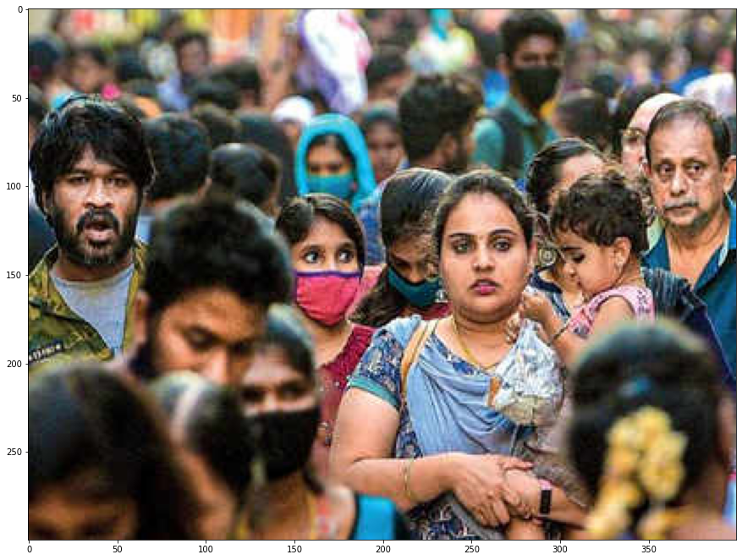

#face_detector = get_detector("resnet50_2020-07-20", max_size=800)

Downloading: "<https://github.com/ternaus/retinaface/releases/download/0.01/retinaface_resnet50_2020-07-20-f168fae3c.zip>" to /root/.cache/torch/hub/checkpoints/retinaface_resnet50_2020-07-20-f168fae3c.zip

100%

96.9M/96.9M [00:01<00:00, 66.7MB/s]

/usr/local/lib/python3.7/dist-packages/torch/hub.py:452: UserWarning: Falling back to the old format < 1.6. This support will be deprecated in favor of default zipfile format introduced in 1.6. Please redo torch.save() to save it in the new zipfile format.

warnings.warn('Falling back to the old format < 1.6. This support will be '

#len(annotations)

18

#print(annotations)

[{'bbox': [233, 108, 281, 172], 'score': 0.9997802376747131, 'landmarks': [[245, 133], [267, 132], [256, 143], [249, 157], [265, 156]]}, {'bbox': [13, 76, 61, 143], 'score': 0.9997445940971375, 'landmarks': [[29, 95], [51, 97], [40, 108], [30, 122], [48, 123]]}, {'bbox': [70, 161, 131, 227], 'score': 0.9990845918655396, 'landmarks': [[96, 188], [121, 193], [109, 206], [92, 212], [108, 216]]}, {'bbox': [299, 124, 329, 160], 'score': 0.9988908171653748, 'landmarks': [[303, 139], [309, 139], [303, 147], [309, 152], [313, 152]]}, {'bbox': [349, 65, 389, 121], 'score': 0.9975659847259521, 'landmarks': [[357, 88], [377, 89], [365, 101], [361, 110], [374, 111]]}, {'bbox': [274, 15, 300, 48], 'score': 0.9972311854362488, 'landmarks': [[284, 27], [295, 27], [291, 34], [286, 40], [294, 39]]}, {'bbox': [156, 77, 181, 108], 'score': 0.9962233304977417, 'landmarks': [[162, 89], [173, 89], [167, 95], [163, 101], [172, 100]]}, {'bbox': [116, 194, 161, 253], 'score': 0.9951901435852051, 'landmarks': [[126, 217], [148, 216], [137, 228], [131, 239], [146, 239]]}, {'bbox': [189, 66, 210, 95], 'score': 0.9926519989967346, 'landmarks': [[195, 77], [204, 76], [200, 83], [197, 89], [205, 88]]}, {'bbox': [146, 120, 186, 173], 'score': 0.9870709776878357, 'landmarks': [[161, 140], [179, 139], [173, 149], [166, 159], [178, 159]]}, {'bbox': [85, 19, 99, 36], 'score': 0.9610177874565125, 'landmarks': [[88, 26], [94, 25], [91, 29], [90, 33], [95, 32]]}, {'bbox': [202, 124, 237, 166], 'score': 0.957653820514679, 'landmarks': [[211, 144], [227, 143], [219, 154], [214, 158], [225, 157]]}, {'bbox': [24, 26, 40, 46], 'score': 0.936183750629425, 'landmarks': [[27, 33], [33, 34], [29, 38], [28, 42], [32, 42]]}, {'bbox': [233, 58, 253, 89], 'score': 0.9314578771591187, 'landmarks': [[247, 70], [250, 70], [252, 76], [246, 82], [249, 82]]}, {'bbox': [335, 57, 362, 98], 'score': 0.9207167625427246, 'landmarks': [[342, 73], [354, 74], [347, 82], [343, 90], [351, 90]]}, {'bbox': [295, 84, 331, 126], 'score': 0.9172001481056213, 'landmarks': [[310, 103], [322, 99], [321, 109], [316, 115], [324, 112]]}, {'bbox': [308, 22, 321, 39], 'score': 0.8581014275550842, 'landmarks': [[314, 28], [319, 28], [317, 32], [314, 35], [317, 35]]}, {'bbox': [195, 36, 216, 59], 'score': 0.7739537358283997, 'landmarks': [[203, 45], [211, 46], [207, 51], [202, 54], [208, 55]]}]

#mask_classifier = get_classifier("tf_efficientnet_b0_ns_2020-07-29")

#mask_classifier.eval();

Downloading: "<https://github.com/ternaus/facemask_detection/releases/download/0.0.1/tf_efficientnet_b0_ns_2020-07-29-ffdde352.zip>" to /root/.cache/torch/hub/checkpoints/tf_efficientnet_b0_ns_2020-07-29-ffdde352.zip

100%

14.4M/14.4M [00:00<00:00, 18.2MB/s]

/usr/local/lib/python3.7/dist-packages/torch/hub.py:452: UserWarning: Falling back to the old format < 1.6. This support will be deprecated in favor of default zipfile format introduced in 1.6. Please redo torch.save() to save it in the new zipfile format.

warnings.warn('Falling back to the old format < 1.6. This support will be '

#predictions[]

100%|██████████| 18/18 [00:04<00:00, 4.42it/s]

#plt.imshow(vis_image)

<matplotlib.image.AxesImage at 0x7fb131417850>

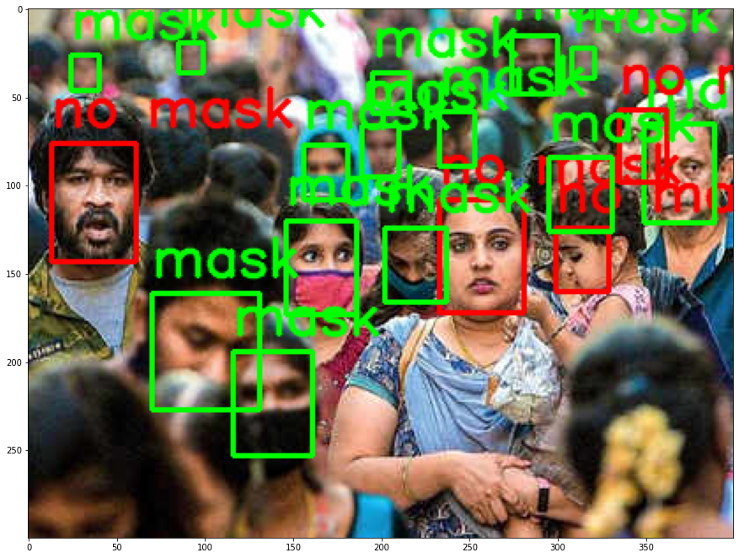

**Result:**

Thus, the module2 was implemented and documented successfully.

**Experiment 10: Module 3 description and implementation**

**Aim**

To implement Module 3 of the project and display the output of the module with solving New Issues.

**Software Used**

**Python**

**Code of Module 3**

**from google.colab import drive**

**drive.mount('/content/drive')**

**from google.colab import drive**

**drive.mount('/content/drive')**

**# import the necessary packages**

**from tensorflow.keras.preprocessing.image import ImageDataGenerator**

**from tensorflow.keras.applications import MobileNetV2**

**from tensorflow.keras.layers import AveragePooling2D**

**from tensorflow.keras.layers import Dropout**

**from tensorflow.keras.layers import Flatten**

**from tensorflow.keras.layers import Dense**

**from tensorflow.keras.layers import Input**

**from tensorflow.keras.models import Model**

**from tensorflow.keras.optimizers import Adam**

**from tensorflow.keras.applications.mobilenet_v2 import preprocess_input**

**from tensorflow.keras.preprocessing.image import img_to_array**

**from tensorflow.keras.preprocessing.image import load_img**

**from tensorflow.keras.utils import to_categorical**

**from sklearn.preprocessing import LabelBinarizer**

**from sklearn.model_selection import train_test_split**

**from sklearn.metrics import classification_report**

**from imutils import paths**

**import matplotlib.pyplot as plt**

**import numpy as np**

**import os**

**# initialize the initial learning rate, number of epochs to train for,**

**# and batch size**

**INIT_LR = 1e-4**

**EPOCHS = 20**

**BS = 32**

**DIRECTORY = r"/content/drive/MyDrive/Face-Mask-Detection-master/dataset"**

**CATEGORIES = ["with_mask", "without_mask"]**

**# grab the list of images in our dataset directory, then initialize**

**# the list of data (i.e., images) and class images**

**print("[INFO] loading images...")**

**data = []**

**labels = []**

**for category in CATEGORIES:**

**path = os.path.join(DIRECTORY, category)**

**for img in os.listdir(path):**

**img_path = os.path.join(path, img)**

**image = load_img(img_path, target_size=(224, 224))**

**image = img_to_array(image)**

**image = preprocess_input(image)**

**data.append(image)**

**labels.append(category)**

**# perform one-hot encoding on the labels**

**lb = LabelBinarizer()**

**labels = lb.fit_transform(labels)**

**labels = to_categorical(labels)**

**data = np.array(data, dtype="float32")**

**labels = np.array(labels)**

**(trainX, testX, trainY, testY) = train_test_split(data, labels,**

**test_size=0.20, stratify=labels, random_state=42)**

**# construct the training image generator for data augmentation**

**aug = ImageDataGenerator(**

**rotation_range=20,**

**zoom_range=0.15,**

**width_shift_range=0.2,**

**height_shift_range=0.2,**

**shear_range=0.15,**

**horizontal_flip=True,**

**fill_mode="nearest")**

**# load the MobileNetV2 network, ensuring the head FC layer sets are**

**# left off**

**baseModel = MobileNetV2(weights="imagenet", include_top=False,**

**input_tensor=Input(shape=(224, 224, 3)))**

**# construct the head of the model that will be placed on top of the**

**# the base model**

**headModel = baseModel.output**

**headModel = AveragePooling2D(pool_size=(7, 7))(headModel)**

**headModel = Flatten(name="flatten")(headModel)**

**headModel = Dense(128, activation="relu")(headModel)**

**headModel = Dropout(0.5)(headModel)**

**headModel = Dense(2, activation="softmax")(headModel)**

**# place the head FC model on top of the base model (this will become**

**# the actual model we will train)**

**model = Model(inputs=baseModel.input, outputs=headModel)**

**# loop over all layers in the base model and freeze them so they will**

**# *not* be updated during the first training process**

**for layer in baseModel.layers:**

**layer.trainable = False**

**# compile our model**

**print("[INFO] compiling model...")**

**opt = Adam(lr=INIT_LR, decay=INIT_LR / EPOCHS)**

**model.compile(loss="binary_crossentropy", optimizer=opt,**

**metrics=["accuracy"])**

**# train the head of the network**

**print("[INFO] training head...")**

**H = model.fit(**

**aug.flow(trainX, trainY, batch_size=BS),**

**steps_per_epoch=len(trainX) // BS,**

**validation_data=(testX, testY),**

**validation_steps=len(testX) // BS,**

**epochs=EPOCHS)**

**# make predictions on the testing set**

**print("[INFO] evaluating network...")**

**predIdxs = model.predict(testX, batch_size=BS)**

**# for each image in the testing set we need to find the index of the**

**# label with corresponding largest predicted probability**

**predIdxs = np.argmax(predIdxs, axis=1)**

**# show a nicely formatted classification report**

**print(classification_report(testY.argmax(axis=1), predIdxs,**

**target_names=lb.classes_))**

**# serialize the model to disk**

**print("[INFO] saving mask detector model...")**

**model.save("mask_detector.model", save_format="h5")**

**# plot the training loss and accuracy**

**N = EPOCHS**

**plt.style.use("ggplot")**

**plt.figure()**

**plt.plot(np.arange(0, N), H.history["loss"], label="train_loss")**

**plt.plot(np.arange(0, N), H.history["val_loss"], label="val_loss")**

**plt.plot(np.arange(0, N), H.history["accuracy"], label="train_acc")**

**plt.plot(np.arange(0, N), H.history["val_accuracy"], label="val_acc")**

**plt.title("Training Loss and Accuracy")**

**plt.xlabel("Epoch #")**

**plt.ylabel("Loss/Accuracy")**

**plt.legend(loc="lower left")**

**plt.savefig("plot.png")**

**Result of Module 3**

**# import the necessary packages**

**# initialize the initial learning rate, number of epochs to train for,\n# and batch size\nINIT_LR = 1e-4\nEPOCHS = 20\nBS = 32\n\nDIRECTORY = r"/content/drive/MyDrive/Face-Mask-Detection-master/dataset"\nCATEGORIES = ["with_mask", "without_mask"]\n\n# grab the list of images in our dataset directory, then initialize\n# the list of data (i.e., images) and class images\nprint("[INFO] loading images...")\n\ndata = []\nlabels = []\n\nfor category in CATEGORIES:\n path = os.path.join(DIRECTORY, category)\n for img in os.listdir(path):\n \timg_path = os.path.join(path, img)\n \timage = load_img(img_path, target_size=(224, 224))\n \timage = img_to_array(image)\n \timage = preprocess_input(image)\n\n \tdata.append(image)\n \tlabels.append(category)\n\n# perform one-hot encoding on the labels\nlb = LabelBinarizer()\nlabels = lb.fit_transform(labels)\nlabels = to_categorical(labels)\n\ndata = np.array(data, dtype="float32")\nlabels = np.array(labels)\n\n(trainX, testX, tr**

**# grab the list of images in our dataset directory, then initialize**

**# the list of data (i.e., images) and class images**

**[INFO] loading images...**

**/usr/local/lib/python3.7/dist-packages/PIL/Image.py:960: UserWarning: Palette images with Transparency expressed in bytes should be converted to RGBA images**

**"Palette images with Transparency expressed in bytes should be "**

**# load the MobileNetV2 network, ensuring the head FC layer sets are**

**# left off**

**WARNING:tensorflow:`input_shape` is undefined or non-square, or `rows` is not in [96, 128, 160, 192, 224]. Weights for input shape (224, 224) will be loaded as the default.**

**Downloading data from** [**https://storage.googleapis.com/tensorflow/keras-applications/mobilenet_v2/mobilenet_v2_weights_tf_dim_ordering_tf_kernels_1.0_224_no_top.h5**](https://storage.googleapis.com/tensorflow/keras-applications/mobilenet_v2/mobilenet_v2_weights_tf_dim_ordering_tf_kernels_1.0_224_no_top.h5)

**9412608/9406464 [==============================] - 0s 0us/step**

**# train the head of the network**

**[INFO] training head...**

**Epoch 1/20**

**52/52 [==============================] - 91s 2s/step - loss: 0.4382 - accuracy: 0.8469 - val_loss: 0.1971 - val_accuracy: 0.9119**

**Epoch 2/20**

**52/52 [==============================] - 87s 2s/step - loss: 0.1902 - accuracy: 0.9266 - val_loss: 0.1223 - val_accuracy: 0.9452**

**Epoch 3/20**

**52/52 [==============================] - 88s 2s/step - loss: 0.1209 - accuracy: 0.9591 - val_loss: 0.0774 - val_accuracy: 0.9833**

**Epoch 4/20**

**52/52 [==============================] - 87s 2s/step - loss: 0.0873 - accuracy: 0.9797 - val_loss: 0.0561 - val_accuracy: 0.9881**

**Epoch 5/20**

**52/52 [==============================] - 87s 2s/step - loss: 0.0640 - accuracy: 0.9834 - val_loss: 0.0425 - val_accuracy: 0.9881**

**Epoch 6/20**

**52/52 [==============================] - 88s 2s/step - loss: 0.0419 - accuracy: 0.9935 - val_loss: 0.0351 - val_accuracy: 0.9881**

**Epoch 7/20**

**52/52 [==============================] - 88s 2s/step - loss: 0.0509 - accuracy: 0.9892 - val_loss: 0.0295 - val_accuracy: 0.9952**

**Epoch 8/20**

**52/52 [==============================] - 88s 2s/step - loss: 0.0372 - accuracy: 0.9945 - val_loss: 0.0255 - val_accuracy: 0.9952**

**Epoch 9/20**

**52/52 [==============================] - 88s 2s/step - loss: 0.0258 - accuracy: 0.9909 - val_loss: 0.0230 - val_accuracy: 0.9976**

**Epoch 10/20**

**52/52 [==============================] - 90s 2s/step - loss: 0.0498 - accuracy: 0.9839 - val_loss: 0.0219 - val_accuracy: 0.9952**

**Epoch 11/20**

**52/52 [==============================] - 88s 2s/step - loss: 0.0298 - accuracy: 0.9894 - val_loss: 0.0198 - val_accuracy: 0.9952**

**Epoch 12/20**

**52/52 [==============================] - 88s 2s/step - loss: 0.0204 - accuracy: 0.9970 - val_loss: 0.0184 - val_accuracy: 0.9952**

**Epoch 13/20**

**52/52 [==============================] - 87s 2s/step - loss: 0.0281 - accuracy: 0.9949 - val_loss: 0.0171 - val_accuracy: 0.9976**

**Epoch 14/20**

**52/52 [==============================] - 88s 2s/step - loss: 0.0230 - accuracy: 0.9914 - val_loss: 0.0161 - val_accuracy: 0.9976**

**Epoch 15/20**

**52/52 [==============================] - 87s 2s/step - loss: 0.0217 - accuracy: 0.9952 - val_loss: 0.0151 - val_accuracy: 0.9976**

**Epoch 16/20**

**52/52 [==============================] - 88s 2s/step - loss: 0.0232 - accuracy: 0.9972 - val_loss: 0.0150 - val_accuracy: 0.9976**

**Epoch 17/20**

**52/52 [==============================] - 87s 2s/step - loss: 0.0146 - accuracy: 0.9975 - val_loss: 0.0139 - val_accuracy: 0.9976**

**Epoch 18/20**

**52/52 [==============================] - 87s 2s/step - loss: 0.0145 - accuracy: 0.9974 - val_loss: 0.0159 - val_accuracy: 0.9929**

**Epoch 19/20**

**52/52 [==============================] - 87s 2s/step - loss: 0.0096 - accuracy: 0.9994 - val_loss: 0.0140 - val_accuracy: 0.9952**

**Epoch 20/20**

**52/52 [==============================] - 87s 2s/step - loss: 0.0195 - accuracy: 0.9953 - val_loss: 0.0170 - val_accuracy: 0.9929**

**# make predictions on the testing set**

**# for each image in the testing set we need to find the index of the**

**# label with corresponding largest predicted probability**

**# show a nicely formatted classification report**

**# serialize the model to disk**

**[INFO] evaluating network...**

**precision recall f1-score support**

**with_mask 0.99 1.00 1.00 383**

**without_mask 1.00 0.92 0.96 37**

**accuracy 0.99 420**

**macro avg 1.00 0.96 0.98 420**

**weighted avg 0.99 0.99 0.99 420**

**[INFO] saving mask detector model…**

**# plot the training loss and accuracy**

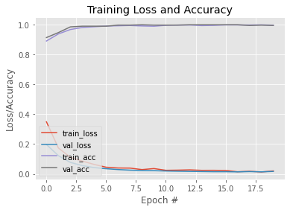

Result:

Thus, the module3 was implemented and documented successfully.

**Experiment 11: Master Test Plan, Test Case Design**

**Aim**

To Prepare master test plan and Test cases for testing the project

**Table of Contents**

***1.*** ***Executive Summary***

***2.*** ***Test Plan***

***2.1.*** ***Scope of Testing***

***2.2.*** ***Types of Testing , Methodology , Tools***

***3.*** ***Test Case***

***3.1.*** ***Functional Test Cases***

***3.1.*** ***Non-Functional Test Cases***

***Reference***

# 

# Executive Summary

The scope to test the software applications is to basically illustrate various areas of a customer’s product that are supposed to get tested. It also gives an insight about various functionalities that are to be focused.

The main objective of testing the software application is to find out the exception cases and to improve the efficiency of the module.

We have adopted black box testing for our first module i.e. (login page).

Our report includes white box testing for the functional test cases wherein the number of test cases executed are 10. Out of which, 8 test cases are successful while 2 test cases are not accurate.

# Test Plan

Whitebox testing for functional and black box testing for non functional requirements.

# Scope of Testing

**Functional:** We took only the second module for testing

**Non-Functional:** All possibilities are covered.

# Types of Testing , Methodology , Tools

|  |  |  |
| --- | --- | --- |
| Category | Methodology | Tools Required |
| Functional Requirements | Unit testing/Whitebox testing | photo input and access to google colab module. |
| Non-Functional Requirements | Blackbox testing | - |

# Test Case

# Functional Test Cases

|  |  |  |  |  |  |  |  |
| --- | --- | --- | --- | --- | --- | --- | --- |
| **Test ID (#)** | **Test Scenario** | **Test Case** | **Execution Steps** | **Expected Outcome** | **Actual Outcome** | **Status** | **Remarks** |
| 1. | Accept valid images which can provide accurate results to display, if the person is wearing a mask. | Input the photo which could categorize people with and without masks.  [**https://drive.google.com/file/d/1YvgBDbCFAEprirXP6ubwQMIIAAwxDq3n/view?usp=sharing**](https://drive.google.com/file/d/1YvgBDbCFAEprirXP6ubwQMIIAAwxDq3n/view?usp=sharing) | Load the image from the link.  Run all the cells to train the image to display expected output. | Annotate the image as with and without mask, image enclosed in bounding boxes. |  |  |  |
| 2. | Accept valid Image which can provide accurate results to display, if the person is wearing a mask | [**https://drive.google.com/file/d/1L5IvLb1NRoV79cjfAELtIJPmMQ1hqraC/view?usp=sharing**](https://drive.google.com/file/d/1L5IvLb1NRoV79cjfAELtIJPmMQ1hqraC/view?usp=sharing) | Load the image from the link.  Run all the cells to train the image to display expected output. | Annotate the image as with and without mask, image enclosed in bounding boxes. |  |  |  |
| 3 | Accept valid Image which can provide accurate results to display, if the person is wearing a mask | [**https://drive.google.com/file/d/14DX_yOL_mFsvdueK5Wh8t-0Q10RvwrAH/view?usp=sharing**](https://drive.google.com/file/d/14DX_yOL_mFsvdueK5Wh8t-0Q10RvwrAH/view?usp=sharing) | Load the image from the link.  Run all the cells to train the image to display expected output. | Annotate the image as with and without mask, image enclosed in bounding boxes. |  |  |  |
| 4 | Accept valid Image which can provide accurate results to display, if the person is wearing a mask | [**https://drive.google.com/file/d/1cvd8B8fFHQMSUHXW5VPtcsN3w7I4avrY/view?usp=sharing**](https://drive.google.com/file/d/1cvd8B8fFHQMSUHXW5VPtcsN3w7I4avrY/view?usp=sharing) | Load the image from the link.  Run all the cells to train the image to display expected output. | Annotate the image as with and without mask, image enclosed in bounding boxes. |  |  |  |
| 5 | Accept valid Image which can provide accurate results to display, if the person is wearing a mask | [**https://drive.google.com/file/d/1t-rhaCeThdxvwmxL67qrckb9PQrifsay/view?usp=sharing**](https://drive.google.com/file/d/1t-rhaCeThdxvwmxL67qrckb9PQrifsay/view?usp=sharing) | Load the image from the link.  Run all the cells to train the image to display expected output. | Annotate the image as with and without mask, image enclosed in bounding boxes. |  |  |  |
| 6. | Accept valid Image which can provide accurate results to display, if the person is wearing a mask | [**https://drive.google.com/file/d/16AB1FMYqULBjU2Jc3VhWRHCDsbptucKy/view?usp=sharing**](https://drive.google.com/file/d/16AB1FMYqULBjU2Jc3VhWRHCDsbptucKy/view?usp=sharing) | Load the image from the link.  Run all the cells to train the image to display expected output. | Annotate the image as with and without mask, image enclosed in bounding boxes. |  |  |  |
| 7. | Accept valid Image which can provide accurate results to display, if the person is wearing a mask | [**https://drive.google.com/file/d/1VbdzNfRW50g6-AEzpa4PXkQP5YZckx1z/view?usp=sharing**](https://drive.google.com/file/d/1VbdzNfRW50g6-AEzpa4PXkQP5YZckx1z/view?usp=sharing) | Load the image from the link.  Run all the cells to train the image to display expected output. | Annotate the image as with and without mask, image enclosed in bounding boxes. |  |  |  |
| 8. | Accept valid Image which can provide accurate results to display, if the person is wearing a mask | [**https://drive.google.com/file/d/1gsqoNsAEFPnGKevwFdL1C313VL_2dw7S/view?usp=sharing**](https://drive.google.com/file/d/1gsqoNsAEFPnGKevwFdL1C313VL_2dw7S/view?usp=sharing) | Load the image from the link.  Run all the cells to train the image to display expected output. | Annotate the image as with and without mask, image enclosed in bounding boxes. |  |  |  |
| 9. | Accept valid Image which can provide accurate results to display, if the person is wearing a mask | [**https://drive.google.com/file/d/11rdYzNXqTAZnzN3H6lU53CtuUm9EP_Wf/view?usp=sharing**](https://drive.google.com/file/d/11rdYzNXqTAZnzN3H6lU53CtuUm9EP_Wf/view?usp=sharing) | Load the image from the link.  Run all the cells to train the image to display expected output. | Annotate the image as with and without mask, image enclosed in bounding boxes. |  |  |  |
| 10. | Accept valid image which can provide accurate results to display, if the person is wearing a mask | [**https://drive.google.com/file/d/1c6pXQ6j4Il-s1QBF4cAAR6hH_xQGik0X/view?usp=sharing**](https://drive.google.com/file/d/1c6pXQ6j4Il-s1QBF4cAAR6hH_xQGik0X/view?usp=sharing) | Load the image from the link.  Run all the cells to train the image to display expected output | Annotate the image as with and without mask, image enclosed in bounding boxes. |  |  |  |

# **3.2 Non-Functional Test Cases :**

|  |  |  |  |  |  |  |  |
| --- | --- | --- | --- | --- | --- | --- | --- |
| **Test ID (#)** | **Test Scenario** | **Test Case** | **Execution Steps** | **Expected Outcome** | **Actual Outcome** | **Status** | **Remarks** |
| 1 | Compatibility. | Software should be installable on all versions of Windows and Mac. | - | Should run on all the platforms. |  |  |  |
| 2 | Performance | Spontaneous identification that a person is wearing a mask or not. | - | It should be efficient in detecting the mask with no time |  |  |  |
| 3 | Survivability | The parameter checks that the software system continues to function and recovers itself in case of system failure. | - | - |  |  |  |
| 4 | Traceability | There is no room for traceability as we are following the Waterfall model. | - | - |  |  |  |
| 5 | Interoperability | Can connect and exchange information with Web Camera computational systems by giving access, without restriction. | We should give access to the web camera through the channel in which we are working. | Should have the access to all the necessary tools in the system which helps to execute the project. |  |  |  |
| 6 | Reliability | Depends on the quality of the camera, and system specifications |  | Efficient in detecting the mask for the images which are not clear. |  |  |  |
| 7 | Efficiency | A software system can handle capacity, quantity and response time. |  | - |  |  |  |
| 8 | Portability | The flexibility of the software to transfer from its current hardware or software environment. | google colab works on every environment. | works |  |  |  |
| 9 | Security | Only the observant who invigilates should be able to view the information / data. | - | Information is secured |  |  |  |
| 10 | Usability | The ease with which the user can learn, operate, prepare inputs and outputs through interaction with a system. | - | Easy to operate by giving the input link and getting the required outcome. |  |  |  |

# Test ReportReference

1. <https://www.pmi.org/>

**Result:**

Thus, the test plan and test cases are documented successfully

**Experiment 12: Manual Testing with Report**

**Aim**

To conduct manual test using Test cases and prepare test report for the project

**Table of Contents**

***1.*** ***Executive Summary***

***2.*** ***Test Plan***

***2.1.*** ***Scope of Testing***

***2.2.*** ***Types of Testing , Methodology , Tools***

***3.*** ***Test Case***

***3.1.*** ***Functional Test Cases***

***3.1.*** ***Non-Functional Test Cases***

***4.*** ***Defect Log***

***5.*** ***Test Report***

***Reference***

# Executive Summary

The scope to test the software applications is to basically illustrate various areas of a product that are supposed to get tested. It also gives an insight about various functionalities that are to be focused.

The main objective of testing the software application is to find out the exception cases and to improve the efficiency of the module.

We have adopted black box testing for our first module i.e. (login page).

Our report includes white box testing for the functional test cases wherein the number of test cases executed are 10. Out of which, 8 number of test cases are successful while 2 test cases are not accurate.

Blackbox testing is adopted for testing the non functional requirements.

# Test Plan

Whitebox testing for functional and black box testing for non functional requirement

# Scope of Testing

**Functional:** We took only the second module for testing .

**Non-Functional:** All possibilities are covered.

# Types of Testing , Methodology , Tools

|  |  |  |
| --- | --- | --- |
| Category | Methodology | Tools Required |
| Functional Requirements | Unit testing/Whitebox testing | photo input and access to google colab module. |
| Non-Functional Requirements | Blackbox testing | - |

# Test Case

# Functional Test Cases

|  |  |  |  |  |  |  |  |
| --- | --- | --- | --- | --- | --- | --- | --- |
| **Test ID (#)** | **Test Scenario** | **Test Case** | **Execution Steps** | **Expected Outcome** | **Actual Outcome** | **Status** | **Remarks** |
| 1. | Accept valid images which can provide accurate results to display, if the person is wearing a mask. | Input the photo which could categorize people with and without masks.  [**https://drive.google.com/file/d/1YvgBDbCFAEprirXP6ubwQMIIAAwxDq3n/view?usp=sharing**](https://drive.google.com/file/d/1YvgBDbCFAEprirXP6ubwQMIIAAwxDq3n/view?usp=sharing) | Load the image from the link.  Run all the cells to train the image to display expected output. | Annotate the image as with and without mask, image enclosed in bounding boxes. | Image displayed with faces bounded and annotated upon the categories.  [**https://drive.google.com/file/d/1PXHbjXBRFwQounmdQYbSdA0NB5bzLghA/view?usp=sharing**](https://drive.google.com/file/d/1PXHbjXBRFwQounmdQYbSdA0NB5bzLghA/view?usp=sharing) | Pass | success |
| 2. | Accept valid Image which can provide accurate results to display, if the person is wearing a mask | [**https://drive.google.com/file/d/1L5IvLb1NRoV79cjfAELtIJPmMQ1hqraC/view?usp=sharing**](https://drive.google.com/file/d/1L5IvLb1NRoV79cjfAELtIJPmMQ1hqraC/view?usp=sharing) | Load the image from the link.  Run all the cells to train the image to display expected output. | Annotate the image as with and without mask, image enclosed in bounding boxes. | [**https://drive.google.com/file/d/1fvY1X7yfshosR267D72lYzyJtPJjkoEB/view?usp=sharing**](https://drive.google.com/file/d/1fvY1X7yfshosR267D72lYzyJtPJjkoEB/view?usp=sharing) | Pass | Success |
| 3 | Accept valid Image which can provide accurate results to display, if the person is wearing a mask | [**https://drive.google.com/file/d/1 DX_yOL_mFsvdueK5Wh8t-0Q10RvwrAH/view?usp=sharing**](https://drive.google.com/file/d/14DX_yOL_mFsvdueK5Wh8t-0Q10RvwrAH/view?usp=sharing) | Load the image from the link.  Run all the cells to train the image to display expected output. | Annotate the image as with and without  mask, image enclosed in bounding boxes. | [**https://drive.google.com/file/d/1LCXqX9b978vnuKdIyWgo1DzD2an1Vqy/view?usp=sharing**](https://drive.google.com/file/d/1LCQXqX9b978vnuKdIyWgo1DzD2an1Vqy/view?usp=sharing) | Pass | Success |
| 4 | Accept valid Image which can provide accurate results to display, if the person is wearing a mask | [**https://drive.google.com/file/d/1cvd8B8fFHQMSUHXW5VPtcsN3w7I4avrY/view?usp=sharing**](https://drive.google.com/file/d/1cvd8B8fFHQMSUHXW5VPtcsN3w7I4avrY/view?usp=sharing) | Load the image from the link.  Run all the cells to train the image to display expected output. | Annotate the image as with and without mask, image enclosed in bounding boxes. | [**https://drive.google.com/file/d/1Pj8xPAn-__TulNFf5jznwYalpxvyd2UW/view?usp=sharing**](https://drive.google.com/file/d/1Pj8xPAn-__TulNFf5jznwYalpxvyd2UW/view?usp=sharing) | Pass | Success |
| 5 | Accept valid Image which can provide accurate results to display, if the person is wearing a mask | [**https://drive.google.com/file/d/1t-rhaCeThdxvwmxL67qrckb9PQrifsay/view?usp=sharing**](https://drive.google.com/file/d/1t-rhaCeThdxvwmxL67qrckb9PQrifsay/view?usp=sharing) | Load the image from the link.  Run all the cells to train the image to display expected output. | Annotate the image as with and without mask, image enclosed in bounding boxes. | [**https://drive.google.com/file/d/1P_yHcYWSKHIGzVl46GOLM2v8jcA0FMlK/view?usp=sharing**](https://drive.google.com/file/d/1P_yHcYWSKHIGzVl46GOLM2v8jcA0FMlK/view?usp=sharing) | Pass | Success |
| 6. | Accept valid Image which can provide accurate results to display, if the person is wearing a mask | [**https://drive.google.com/file/d/16AB1FMYqULBjU2Jc3VhWRHCDsbptucKy/view?usp=sharing**](https://drive.google.com/file/d/16AB1FMYqULBjU2Jc3VhWRHCDsbptucKy/view?usp=sharing) | Load the image from the link.  Run all the cells to train the image to display expected output. | Annotate the image as with and without mask, image enclosed in bounding boxes. | [**https://drive.google.com/file/d/1P4lT8yYGiiNq5wJSDjn8qX-tAmAnzY1K/view?usp=sharing**](https://drive.google.com/file/d/1P4lT8yYGiiNq5wJSDjn8qX-tAmAnzY1K/view?usp=sharing) | Pass | Success |
| 7. | Accept valid Image which can provide accurate results to display, if the person is wearing a mask | [**https://drive.google.com/file/d/1VbdzNfRW50g6-AEzpa4PXkQP5YZckx1z/view?usp=sharing**](https://drive.google.com/file/d/1VbdzNfRW50g6-AEzpa4PXkQP5YZckx1z/view?usp=sharing) | Load the  image from the link.  Run all the cells to train the image to display expected output. | Annotate the image as with and without mask, image enclosed in bounding boxes. | [**https://drive.google.com/file/d/1GSj12kn2v9h6qLcWwCtbE7mwJbx3_gGZ/view?usp=sharing**](https://drive.google.com/file/d/1GSj12kn2v9h6qLcWwCtbE7mwJbx3_gGZ/view?usp=sharing) | Pass | Success |
| 8. | Accept valid Image which can provide accurate results to display, if the person is wearing a mask | [**https://drive.google.com/file/d/1gsqoNsAEFPnGKevwFdL1C313VL_2dw7S/view?usp=sharing**](https://drive.google.com/file/d/1gsqoNsAEFPnGKevwFdL1C313VL_2dw7S/view?usp=sharing) | Load the  image from the link.  Run all the cells to train the image to display expected output. | Annotate the image as with and without mask, image enclosed in bounding boxes. | [**https://drive.google.com/file/d/1ZLmML2Wt1eGVxmvqTcqnMsLT_Ho5uyw8/view?usp=sharing**](https://drive.google.com/file/d/1ZLmML2Wt1eGVxmvqTcqnMsLT_Ho5uyw8/view?usp=sharing) | Pass | Success |
| 9. | Accept valid Image which can provide accurate results to display, if the person is wearing a mask | [**https://drive.google.com/file/d/11rdYzNXqTAZnzN3H6lU53CtuUm9EP_Wf/view?usp=sharing**](https://drive.google.com/file/d/11rdYzNXqTAZnzN3H6lU53CtuUm9EP_Wf/view?usp=sharing) | Load the image from the link.  Run all the cells to train the image to display expected output. | Annotate the image as with and without mask, image enclosed in bounding boxes. | [**https://drive.google.com/file/d/1IrMDaRd3ZVt3_AHKStByexXHq0ReuQMh/view?usp=sharing**](https://drive.google.com/file/d/1IrMDaRd3ZVt3_AHKStByexXHq0ReuQMh/view?usp=sharing) | Pass | Success |

# Non-Functional Test Cases

|  |  |  |  |  |  |  |  |
| --- | --- | --- | --- | --- | --- | --- | --- |
| **Test ID (#)** | **Test Scenario** | **Test Case** | **Execution Steps** | **Expected Outcome** | **Actual Outcome** | **Status** | **Remarks** |
| 1 | Compatibility. | Software should be installable on all versions of Windows and Mac. | google colab works on every environment. | Should run on all the platforms. | Had run on all the platforms. | Pass | Success |
| 2 | Performance | Spontaneous identification that a person is wearing a mask or not. | - | It should be efficient in detecting the mask with no time | It is well efficient in detecting the mask in stipulated time. | Pass | Success |
| 3 | Survivability | The parameter checks that the software system continues to function and recovers itself in case of system failure. | - | - | - | Not yet started |  |
| 4 | Traceability | There is no room for traceability as we are following the Waterfall model. | - | - | - | Not yet started |  |
| 5 | Interoperability | Can connect and exchange information with Web Camera computational systems by giving access, without restriction. | We should give access to the web camera through the channel in which we are working. | Should have the access to all the necessary tools in the system which helps to execute the project. | we could access all the tools which help to execute the project successfully. | Pass | Success |
| 6 | Reliability | Depends on the quality of the camera, and system specifications | - | Efficient in detecting the mask for the images which are not clear. | It’s not efficiently handled. | Fail | We would try to improve it based on the further implementations |
| 7 | Efficiency | A software system can handle capacity, quantity and response time. | - | - | - | Not yet started |  |
| 8 | Portability | The flexibility of the software to transfer from its current hardware or software environment. | google colab works on every environment. | works | Result as expected | Pass | Success |
| 9 | Security | Only the observant who invigilates should be able to view the information / data. | - | Information is secured | Result as expected | Pass | Success |
| 10 | Usability | The ease with which the user can learn, operate, prepare inputs and outputs through interaction with a system. | - | Easy to operate by giving the input link and getting the required outcome. | Result as expected | Pass | Success |

# Defect Log

|  |  |  |  |  |
| --- | --- | --- | --- | --- |
| **Requirement #** | **Defect ID #** | **Defect Description** | **Assignee** | **Status** |
| M1R1 | M1R1D1 | The module couldn’t be integrated with the front end. | Divya | Pending  *lack of knowledge. |
| M1R2 | M1R2D2 | Login credential couldn’t be verified | Dinesh | Pending  *PHP not known |
| M1R3 | M1R3D3 | Web page to directly take link as input couldn’t be established | Divya,Anushka | Pending |
| M3R4 | M1R4D4 | Couldn’t link directory to dataset | Anushka | Solved |
| M2R1 | M2R1D5 | Couldn’t integrate the web camera with the module which we are working on. | Anushka, Dinesh | Could be solved by changing the platform. |

# Test Report

Testing was done with what was implemented.

As the frontend couldn't be integrated with the module or backend part with our present knowledge full testing is not possible .

|  |  |  |
| --- | --- | --- |
| **Category** | **Progress Against Plan** | **Status** |
| Functional Testing | Green | Completed |
| Non-Functional Testing | Amber | In-Progress |

|  |  |  |
| --- | --- | --- |
| **Functional** | **Test Case Coverage (%)** | **Status** |
| Module 1 | 30% | In-Progress |
| Module 2 | 100% | Completed |
| Module 3 | 30% | In-Progress |

# 

# Reference

1. <https://www.pmi.org/>

Result:

Thus, the software test conducted and documented the report successfully.

## 

## 

## 

## **Approval**

|  |  |  |  |
| --- | --- | --- | --- |
| **Name** | **Designation** | **Role in Project** | **Signature** |
| Mrs. Anupama G | Faculty -In charge | Evaluator |  |

# 